A Closer Look at the "Dynamics" in Population Dynamics
Central to the analysis of population dynamics are concepts that come naturally to anyone trained in the physical sciences. In elementary physics classes, for example, a physical system is most frequently looked at from the point of view of stability and equilibrium. When engineers design systems, in fields from from aerospace to industrial management, one of the first questions asked is, Under what conditions will the system be at equilibrium, and will it be stable or not? Ecologists also began by asking such questions of ecosystems. As a consequence, concepts such as balance (equilibrium) and stability have become central to both mathematical and conceptual analyses of all ecosystems, especially in population and community ecology. Often such concepts have even become normative, central goals toward which we must strive in the design of sustainable resource management systems. Some ecosystems are reportedly unstable and have lost the inherent equilibria of natural ecosystems (Altieri 1987; Soule et al. 1990), and the job of good husbandry should be to promote the use of management tools that will restore balance and stability, and therefore sustainability, to the system (Altieri 1987; Levins and Vandermeer 1989). Such is a widely held position.
In population and community ecology, such ideas have been debated and clarified over the past 20 years and their meanings operationalized to a considerable extent. Furthermore, this operationalization forced a rethinking of some central concepts. To take a concrete example, one of the ideas that has seen a great deal of rethinking is that the complexity of a system is related to its stability. Metaphorically, as a system becomes larger, it develops more interconnections and, much as in the case of a spider web, those interconnections make it resilient to outside perturbations and thus stable-the more interconnections (read, the larger and more complex the system), the more stable it should be. However, the notion that a large, highly connected system would be more stable than a small system with low connectivity was challenged by
May (1974), who proved that, all else being equal, the larger and more complex the system, the more likely it is to be unstable, precisely the opposite of what most ecologists intuitively felt. Rather than being like a spider web that receives its stability from all of the interconnections within it, food webs appeared to be like houses of cards, deriving their structure from the myriad connections among parts but becoming more fragile the larger they are.
The original intuition of ecologists was that large ecosystems, with their great biodiversity and complex interconnections, are more stable and more in "balance" (at equilibrium) than are simplified systems that have purposefully been designed to eliminate much of that complexity. It seems an obvious idea, so how can it be that careful analytical thought suggests otherwise? One of the problems, perhaps the principal problem, is that these early conceptualizations were based on classical notions of dynamics (stability, equilibrium, and balance) from the physical sciences. With those notions coupled with the semiromantic notion of the balance of nature, a mainstay of nature lovers and environmental activists alike, a perceived concatenation of the popular with the scientific created what seemed to be an unassailable principle. But a false analogy had been built up between the naturalists' notion of balance and stability and the classical engineer's notion of those same things. With more modern interpretations of the underlying dynamic structure of these and other concepts, largely derived from the new science of nonlinear dynamic systems, a new classification of dynamic behaviors may better correspond to the old naturalists' or traditional farmers' original intuition (Vandermeer et al. 2010). Appreciation of this idea will be enhanced by the material offered in this chapter.
EXERCISES
4.1 The integrated form of the logistic equation is
$$N_{t}=\frac{KN_{0}}{\left(K−N_{0}\right)e^{−rt}+N_{0}}.$$
Use this equation to generate a time series of $N$ versus $t$. Use parameters $r=1.5,K=$ 100 and construct two time series, one with $N_{0}=10$ and one with $N_{0}=190$. (Use a time frame from 1 to 5 with intervals of 0.1.)
4.2 Repeat exercise 4.1 with $r=−0.1$. (Use a time frame from 0 to 100 with intervals of at least 1.0.)
4.3 Recall the population model of the Ricker equation from chapter 1 ,
$$N_{t+1}=rN_{t}e^{\left(1−bN_{t}\right)}.$$
Let $r=2.5$ and $b=2.5$ and project the population 45 time units, beginning with a starting population of 0.01 . What is the pattern of the time series? Let $r=4$ and $b=0.7$ and project the time series 45 times, beginning with a starting population of 3.5 . Now what is the pattern of the time series?
4.4 A simple model of predator $(P)$ and prey ( $V$, for victim) interacting in discrete time is, for the prey,
$$V_{t+1}=bV_{t}\left(\frac{K−V_{t}}{K}\right)e^{−aP_{t}}$$
and for the predator,
$$P_{t+1}=cV_{t}\left(1−e^{−aP_{t}}\right).$$
This model will be developed more fully in chapter 6 . For now just examine the time series it generates. Use the parameters $a=0.1,b=1.5,K=40$, and $c=1.5$. Make a graph of the two species over time (from 0 to 200), and plot the two species on a graph of predator versus prey, showing the direction of change with arrows.
4.5 An even simpler model (again, to be developed in chapter 6) is
$$\begin{matrix} & V_{t+1}=bV_{t}−mV_{t}P_{t}, \\ & P_{t+1}=b^{′}V_{t}P_{t}−m^{′}P_{t}.\end{matrix}$$
Repeat exercise 4.4 with this model and the parameters $b=1.1,m=0.8,b^{′}=0.5$, and $m^{′}=0.002$.
Intuitive Ideas of Equilibrium and Stability
The intuitive notions of balance and stability have their parallels in classical analytical thought, balance as equilibrium and stability as one of two forms, either unstable or stable. Consider the graph in figure 4.1. The variable $x$ could be any interesting variable, but for our purposes it is best to think of it as population density. Plotting density over time, beginning at various starting points, we see that no matter where the trajectory begins, it always ends up at the value $x^{∗}$. Furthermore, once it attains the value of $x^{∗}$ it never deviates. The value $x^{∗}$ is thus an equilibrium point (the system is in "balance" once it reaches that point). However, that the system is in balance is only one feature of $x^{∗}$ that is important. The behavior of the variable $x$ when it is not exactly at that equilibrium point is also of great importance. Although it is true that when the system is at equilibrium (the variable $x$ exactly equals $x^{∗}$ ) it will remain there in perpetuity, it is also true that the slightest deviation from that value (say, to the point labeled "deviation from equilibrium" in figure 4.1) will result in a return to that same equilibrium. Because any such deviation will result in a return to the same equilibrium point, the point is a "stable" equilibrium point.
In contrast, consider the situation presented in figure 4.2. Again there is an equilibrium point ( $x^{∗}$ ), and again, if the system is initiated at exactly that point, it will remain there in perpetuity. But the slightest deviation from that point means the system will deviate forever. Thus the point is in balance and it is an equilibrium point because it will stay where it is forever if undisturbed. However, in this case the slightest deviation results in continued deviation. This is referred to as an unstable equilibrium point.
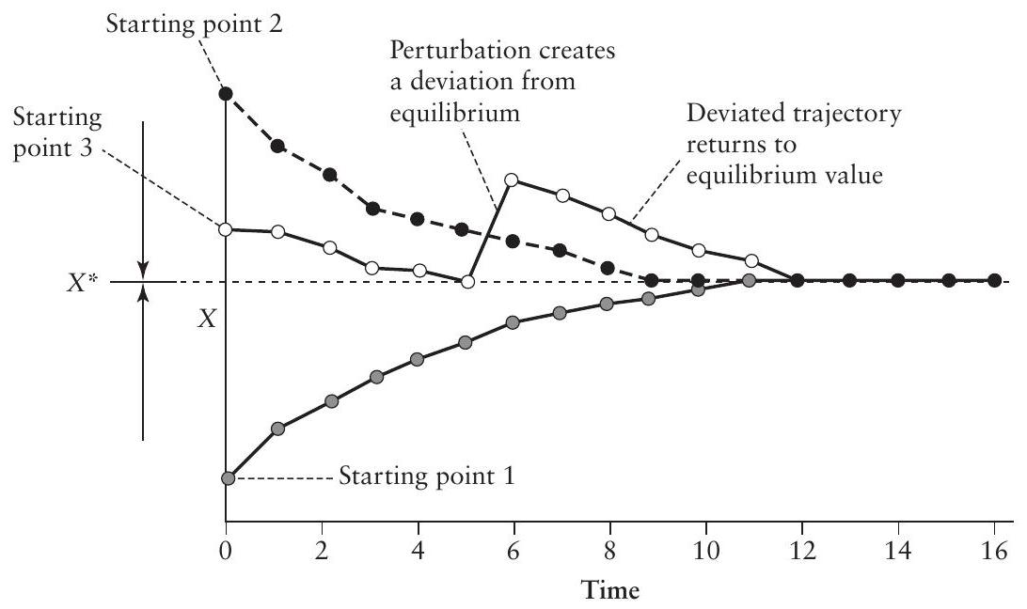
FIGURE 4.1. Illustration of the dynamical behavior associated with a point attractor.
In the past, equilibrium points have been called fixed points, singularities, and probably other things as well. The adjective stable or unstable is then attached to indicate the dynamic behavior of points near that singularity (or fixed point or equilibrium point). In more recent literature, the notion of the equilibrium itself and the behavior of points near to it has been termed either an attractor (for a stable equilibrium point) or a repeller (for an unstable equilibrium point). The terms attractor and repeller are more suitable for discussion given the recent advances in our understanding of models that have
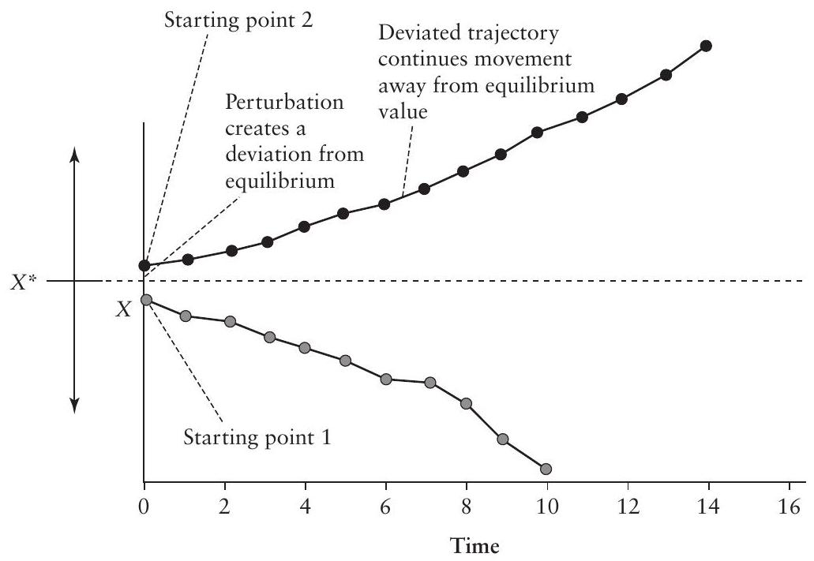
FIGURE 4.2. Illustration of the dynamical behavior of a point repeller.
the sort of complexity demanded by ecological systems. In the rest of this text, when the subject arises the terms attractor and repeller will be used rather than stable equilibrium and unstable equilibrium.
To rapidly picture the dynamics of a system it is often convenient to simply represent the attractor or the repeller as a point on the line that represents the possible range of the variable in question (the ordinate in figures 4.1 and 4.2), with small arrows indicating the direction in which the trajectories near to the equilibrium point will go. The line is called the state space (i.e., the space, in the mathematical sense, that represents all possible values or "states" of these variables, called state variables), and the collection of arrows is called the vector field. When the arrows point toward the equilibrium point (as in figure 4.1) it is an attractor, and when the arrows point away from the equilibrium point (as in figure 4.2) it is a repeller. Thus an examination of the vector field reveals whether a point is an attractor or a repeller or something else.
It is also popular to indicate the dynamics of a system by means of small physical models, as in figure 4.3. The marble on top of the hill (figure 4.3A) illustrates a repeller (the line below it with the point and the arrows is equivalent to the ordinate of figure 4.2 turned on its side), and the marble at the bottom of the valley (figure 4.3B) illustrates an attractor. Because the attractor and the repeller are single points, they are called a point attractor and a point repeller.
Another major category of behavior is not representable in such simple diagrams but requires a two-dimensional space (three-dimensional including time). Suppose we have a beaker of water whose bottom has the positive end of a magnet affixed to its center. We then drop a smaller magnet into the beaker with its negative pole facing downward and watch what it does as it falls through the water. In figure 4.4A the mobile magnet falls toward the magnet on the bottom. If it is placed in the water at exactly the center of the beaker, it will remain in this position (actually somewhere above this position) as it falls
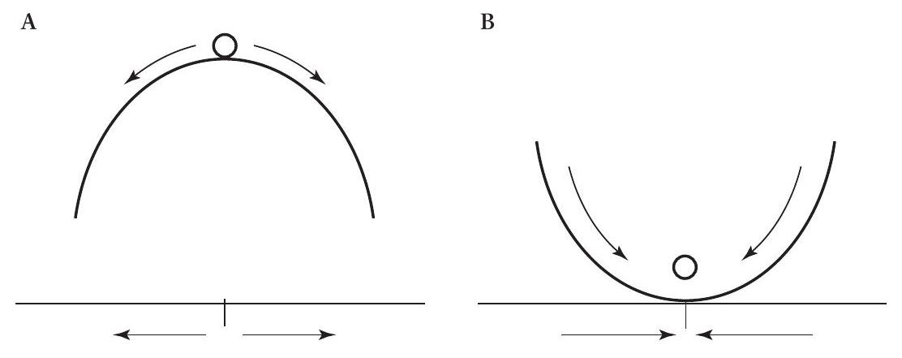
FIGURE 4.3. Physical models of a classical attractor and repeller. (A) The marble is balanced on top of the hill at equilibrium, but the slightest deviation from that point results in continued deviation, corresponding to the situation in figure 4.2. (B) The marble is located in the valley, and all deviations from that point result in a return to it, corresponding to the situation in figure 4.1.
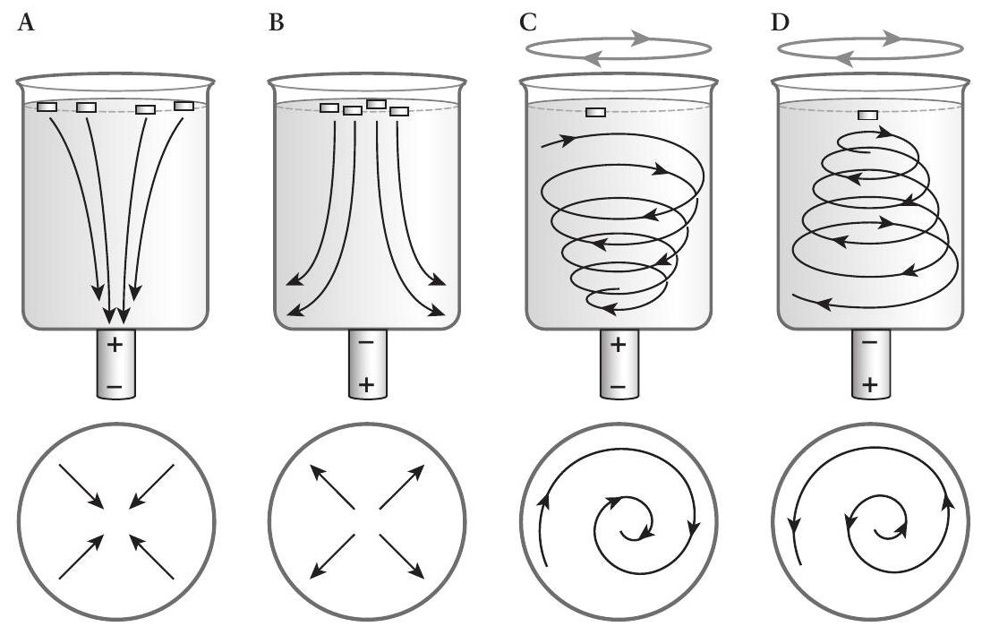
FIGURE 4.4. Beaker and magnet model of dynamics. (A) The small magnets in the water, with their negative poles pointed downward, are attracted to the positive pole of the magnet on the bottom of the beaker. (B) The small magnets are repelled from the negative pole on the bottom of the beaker. (C) When the beaker is constantly rotated, the magnet undergoes a spiraling motion as it descends through the water toward the positive pole of the magnet on the bottom. (D) When the beaker is constantly rotated, the magnet undergoes a spiraling motion as it descends through the water away from the negative pole of the magnet on the bottom. The circle at the bottom of each diagram illustrates the general behavior of the small magnet as viewed from the top (or bottom) of the beaker.
through the water. If it is placed somewhere deviant from this position, it will fall toward the bottom magnet. Obviously this physical model is identical to the example in figure 4.1 except that it is in three dimensions, the horizontal two dimensions of the bottom or top of the beaker and the vertical dimension that represents time (the position from the top of the beaker to the bottom is proportional to the time since the small magnet was dropped into the beaker). Just as we could represent the behavior of the system on a line (the ordinates in figures 4.1 and 4.2 and the lines below the diagrams in figure 4.3), we can do so by looking at just the bottom of the beaker, as shown in the circle below each diagram of the beaker in figure 4.4. Figure 4.4A represents an attractor, and figure 4.4B represents a repeller.
With the beaker model we can see another class of behavior that is extremely important in ecological models. Suppose the beaker is placed on a mixing table that creates a vortex in the water. The expectation is that whatever is dropped into the beaker will spiral around as it drops through the water, as indicated in figure 4.4C. However, as it spirals around it is also attracted by the magnet on the bottom of the beaker. For obvious reasons this attractor is referred to as an oscillatory point attractor. The parallel behavior of the repelling magnet in swirling water is also oscillatory, but it is a
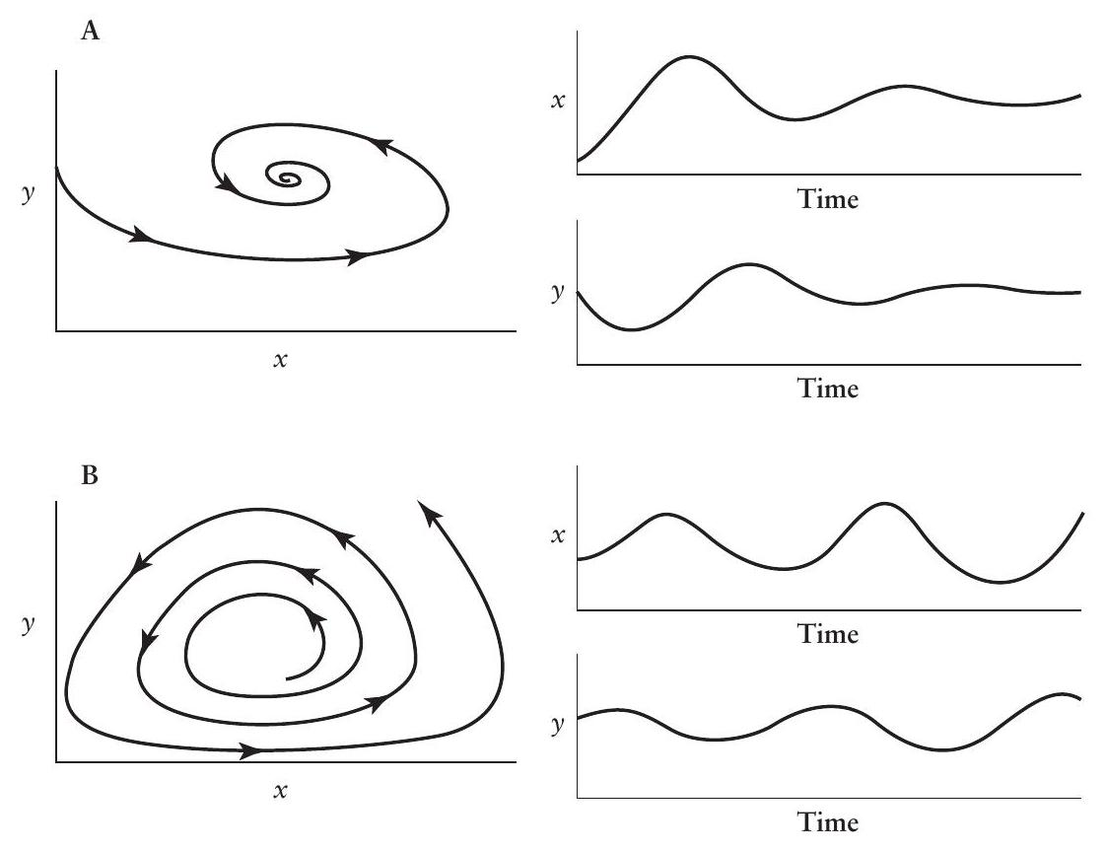
FIGURE 4.5. Traditional representations of an oscillatory attractor (A) and an oscillatory repeller (B). $x$ represents prey, and $y$ represents predator. The graph of $y$ versus $x$ is the traditional "phase plane" diagram. The same data are plotted to the right as a time series in both variables.
repeller-an oscillatory point repeller (figure 4.4D). For each of the oscillatory points (attractor and repeller) the picture on the bottom of the beaker is a spiral (figure 4.4C and D).
Figure 4.5 illustrates how this spiraling behavior looks in a more traditional diagram of the variables over time. The two dimensions of the beaker's bottom are plotted over time to illustrate that an oscillatory attractor is the same as "damped" oscillations, whereas an oscillatory repeller is the same as expanding oscillations.
Yet another class of behavior is extremely important in physical as well as biological systems. This class requires a different physical model, as illustrated in figure 4.6.A. A small hill in the middle of a valley causes a marble to roll down the hill but to become entrapped in the valley, rolling continuously around the bottom of the valley. The sides of the valley cause any marble beginning on that surface to wind down the valley floor, again rolling around the bottom of the valley. The ultimate fate of any trajectory is either to move to the outer limits of the hill or to wind up cycling forever in the bottom of the circular valley (presuming that there is some sort of energy that keeps the system in motion). This kind of behavior is known as a periodic attractor, so named because at some time in the future the system always returns to the same position, which is to say that it periodically returns to any given state. Note that the example in figure 4.6A actually includes two periodic cycles,
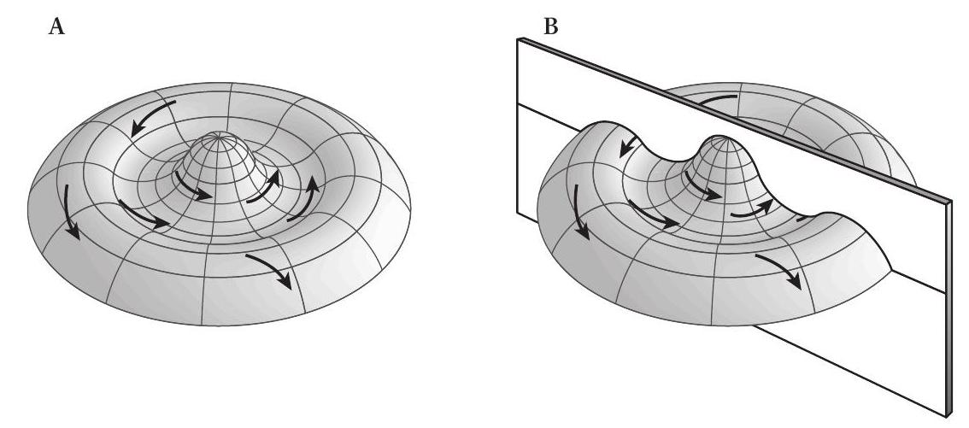
FIGURE 4.6. Physical model illustrating a periodic attractor (limit cycle) (see text).
an obvious one at the bottom of the valley and a not-so-obvious one exactly on the outer edge of the valley. That is, it is theoretically possible to have a marble cycling around the top of the outer boundaries of the valley, always exactly balanced between the force attracting it down to the valley bottom and the force attracting it down off of the side of the hill. Obviously this limit cycle cannot really be observed because the marble cannot be expected to maintain exactly this balance. It is thus an unstable cycle or a periodic repeller.
Taking a cross section of this model (figure 4.6B), we arrive at the more easily interpretable section pictured in figure 4.7 (such a section is formally a Poincaré section). As before, we can summarize the overall behavior of the system with little arrows on the line. Here we see three repellers and two attractors, although the two attractors are simply two points on the periodic
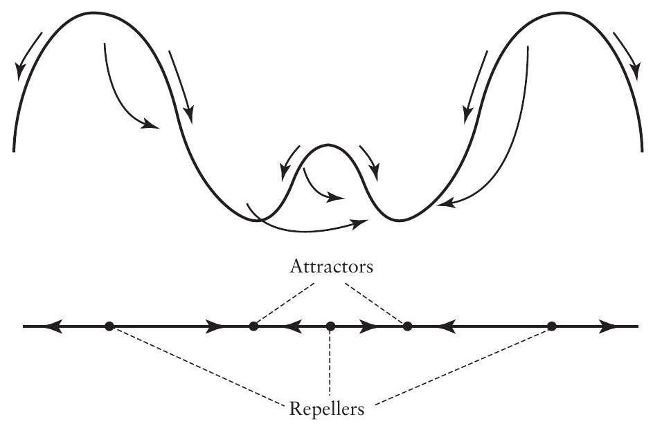
FIGURE 4.7. Cross section (Poincaré section) through the surface of figure 4.6, showing how the dynamics of the system can be illustrated.
attractor and the two outer repellers are simply two points on the periodic repeller. Thus they are not really equilibrium points, as in previous examples, but rather points on an attractor (or points on a repeller).
The final type of qualitatively distinct behavior that is commonly observed in ecological models results if we assume that the bottom of the valley is perfectly flat. If the beaker model of figure 4.4 has the magnets removed from the base or if the hill model of figure 4.6 has its bottom constructed to be absolutely flat, the physical attraction (the magnet in the beaker model, the force of gravity in the hill model) has been removed and we theoretically expect the system to move around in this space, constrained to be sure but without a tendency to move to the center within that space, as suggested by the model in figure 4.8. As before, there are three repellers but no attractors, at least not of the sort in previous examples. Yet the entire bottom of the valley will certainly attract the marble, and in this intuitive sense it is also an attractor. But here we have an attractor that is neither a point nor a cycle but rather an area or region. Being a region that attracts all trajectories yet has no tendency within it to move to the center (no point attractor), it is thought to be rather strange. This is why it is referred to as a strange attractor, and the behavior of a system within it is referred to as chaotic.
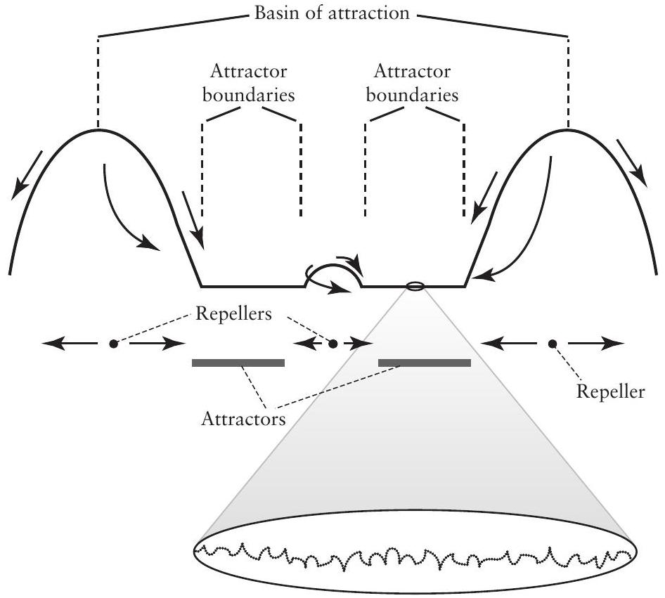
FIGURE 4.8. Poincaré section similar to that in figure 4.7 but with a strange attractor rather than a periodic attractor. The bottom of the valley is, theoretically, perfectly flat, so there is no natural place to which the marble will be attracted. So the entire flat region will attract the marble because the walls of the valley still slope downward. But once it reaches the floor of the valley, its motion will become unpredictable. This is a strange attractor.
Obviously there is a qualitative difference between this type of attractor and those discussed previously. There is no particular point to which the system ultimately tends but rather an area to which it tends. Furthermore, from a practical standpoint we cannot be interested in the final state of the system because it has multiple final states (in the sense of a single point). The concern really ought to be with the range within which the system will ultimately be found, as discussed below.
The class of behaviors illustrated by the simple hills (figure 4.3 and 4.6) or the beakers (figure 4.4) are the classical behaviors usually analyzed by engineers. Certainly they are also important points of departure for analyzing ecological systems. However, there are other kinds of behaviors, most importantly those illustrated in figure 4.8 , in which the focus is on the range of expected values and the persistent changes through time within that range. In summary, attractors (or repellers) can be thought of as falling on a gradient going from simple point attractors (or stable equilibria, stable nodes, stable fixed points-all synonyms-as in figure 4.3) to oscillatory attractors (or stable foci-still point attractors-as in figure 4.4C) to periodic attractors (also called limit cycles) to strange attractors (or chaotic attractors, as in figure 4.8; the subject of chaos will be discussed later in this chapter).
One's interest in analyzing a system depends on the nature of the equilibrium state. If a point equilibrium exists, for example, a central question is how to locate the exact position of the point and determine whether it is an attractor or a repeller. This is the focus of the classical engineering sciences. But if a strange attractor exists, the interest is more in locating the position of its boundaries and discovering other details about its "morphology," as discussed later.
One further concept is especially important when dealing with strange attractors. The "basin of attraction" is the collection of the values of the state variables from which all trajectories eventually wind up exactly on the attractor. In figure 4.7, for example, the tops of the two largest hills represent the outer edges of the basin of attraction for the limit cycle attractor at the bottom of the valley, and the small hill in the middle represents the inner edge of that basin. The edges of a basin of attraction are always repellers, as is evident in figure 4.7. The edges of the basin of attraction are not the same as the boundaries of a strange attractor. The latter refer to the outer limits that the attractor itself can realize, the former to all possible states that eventually reach the attractor. Formally speaking, the attractor (and its boundaries) is a subset of the basin of attraction but not the reverse (see, for example, figure 4.8).
Classical ecological theory has dealt mainly with point attractors and to some extent with periodic attractors. Only with the advent of nonlinear dynamics as a theoretical science has there been a realization that the alternative type of equilibrium and stability actually exists, that is, the strange attractor. Such attractors become more common in the literature as old models are analyzed more completely and especially as new model situations are explored. These attractors have also received considerable attention simply because they are sometimes called chaos or chaotic attractors. This unfortunate choice of terminology will be further discussed later in this chapter.
For now suffice it to say that a strange attractor, because of its so-called chaotic motion, is unpredictable in a very special technical sense. This fact has caused considerable unnecessary consternation among those who seek to predict natural phenomena and has led to a small cottage industry of researchers attempting to show that particular data sets do or do not represent true chaotic behavior. However, the importance of the issue lies not with the distinction between chaos and nonchaos, despite what popular articles contend, but rather with the distinction among point, periodic, and strange attractors, three positions on a continuum from point to strange, as discussed above. In the case of point attractors we are concerned with the location of the equilibrium and its stability properties. In the case of strange attractors we are concerned with their boundaries and qualitative behaviors, their morphology.
EXERCISES
4.6 The basic exponential equation describes the dynamics of a single population, which means that it is a dynamic system in one dimension. Its only equilibrium value is $N^{∗}=0$. Draw the state space (a line), showing with small arrows the dynamical nature of the system near the equilibrium point. Make a graph of the derivative $(dN/dt)$ as a function of $N$ for $r=1.0$ and 1.5.
4.7 The logistic equation also describes the dynamics of a single population but with two equilibrium points, $K$ and 0 . Draw the state space showing the dynamical nature of the system near the equilibrium points. Make a graph of the derivative $(dN/dt)$ as a function of N for $r=1.0,K=1.2$; for $r=1.5,K=1.2$; and for $r=1.5,K=1.8$.
4.8 If you have a single population model based on a single well-behaved ordinary differential equation and it has five equilibrium points and diverges to infinity at very large values, what must the collection of vectors (formally called the vector field) look like (again, on a single line, the relevant state space)? Sketch what you think a graph of $dN/dt$ versus $N$ would look like.
4.9 Assume that a population is growing according to the logistic equation. To make things simple, presume that the value of both $r$ and $K$ is 1.0 (i.e., we represent the population as varying between 0 and 1 ). The equilibrium value of that population will be
$$0=N−N^{2},$$
which is a quadratic equation and has two roots, which are, by inspection, 0 and 1 . Now suppose that a manager decides to impose a fixed harvesting rate on the population such that a constant number of individuals will be removed each year. A sensible model for this situation would be
$$\frac{dN}{dt}=N(1−N)−N_{F},$$
where $N_{F}$ is the fixed number (actually the proportion) of individuals removed. Plot the derivative versus $N$ for the following values of $N_{F}:0,0.25$, and 0.5 . Also, directly solve for the roots (using the quadratic formula; remember, $N_{F}$ is a constant). What do you conclude?
Eigenvalues: A Key Concept in Dynamic Analysis
Consider a simple point attractor in one dimension. As above, we can represent its qualitative dynamics by drawing the state space (a line) and indicating where the point is in that space (on that line) and then adding the vector field (small arrows indicating the direction and rate of change), as presented in figure 4.9.
If we now rotate the vectors 90 degrees, either upward to illustrate an increasing vector or downward to illustrate a decreasing vector, we get the picture shown in figure 4.10. If we connect the tips of the rotated arrows with a line, the slope of that line is called the eigenvalue. With this formulation (figure 4.10) it is evident what the eigenvalue means in this case; it is the rate at which the system approaches a point attractor (or leaves a point repeller, if the rotated arrows go in the opposite direction).
To relate the general concept of eigenvalues to population-dynamic models, recall the exponential equation from chapter 1 ,
$$\frac{dN}{dt}=rN.$$
This is a system of one dimension (a single variable, $N$ ), and thus its state space and dynamics are as in figure 4.9. The equilibrium point is at $N=0$, so the left side of the state space does not exist for this model. Suppose that $r<0$,
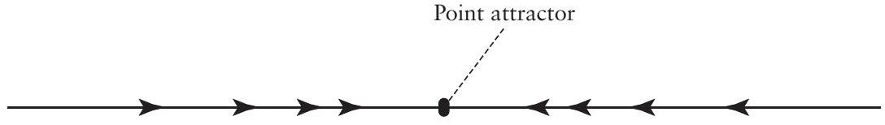
FIGURE 4.9. State space for a one-dimensional (one-variable) model, illustrating a single point attractor and its vector field (the collection of arrows indicating the dynamics of the system).
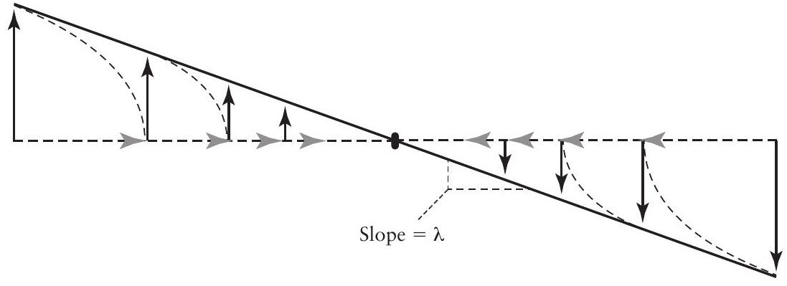
FIGURE 4.10. The vectors of the example from figure 4.9 rotated. The vectors to the right of the point attractor are decreasing, so we rotate them downward (decreasing). The vectors to the left of the point attractor are increasing, so we rotate them upward (increasing). Then we connect the arrowheads with a line. The slope of the line is the eigenvalue of the point attractor.
which is to say, a declining population, one that will eventually go locally extinct. A plot of $dN/dt$ versus $N$ will look something like the right side of figure 4.10 with the slope $=r$. That is, because the vectors represent $dN/dt$ at particular values of $N$, rotating them 90 degrees is the same as plotting them on the $y$ axis. Thus we see that, in this example, the eigenvalue of the attractor is $r$ (because a plot of $dN/dt$ against $N$ is linear in the case of the exponential equation).
If the population is growing $(r>0)$, the result is qualitatively different in that the arrows will all be pointing away from the equilibrium point, that is, the point is a repeller (the equilibrium point is still zero). Thus the arrows to the right of the point will be rotated clockwise (the opposite of what we see in figure 4.10), and again the part of the graph to the left of the point does not exist for this model. The line connecting the arrowheads will thus have a positive slope, which means a positive eigenvalue.
Now, suppose that we have a population growing according to the logistic equation. Its dynamics (again in one dimension) will look something like what is pictured in figure 4.11.
Here we have two equilibrium points, one an attractor at the carrying capacity and one a repeller at the value of zero. If we now rotate the arrows, as before, we obtain the graph shown in figure 4.12.
Here there is no simple slope to the line, but in the neighborhood of each of the equilibrium points we can approximate the curve with a straight line, and the slope of that straight line is the eigenvalue associated with the equi-
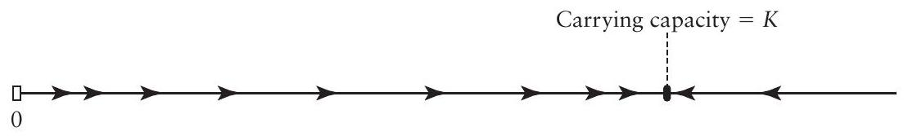
FIGURE 4.11. State space for a one-dimensional model based on the logistic equation. There are two equilibrium points, one an attractor $(K)$, the other a repeller $(0)$.
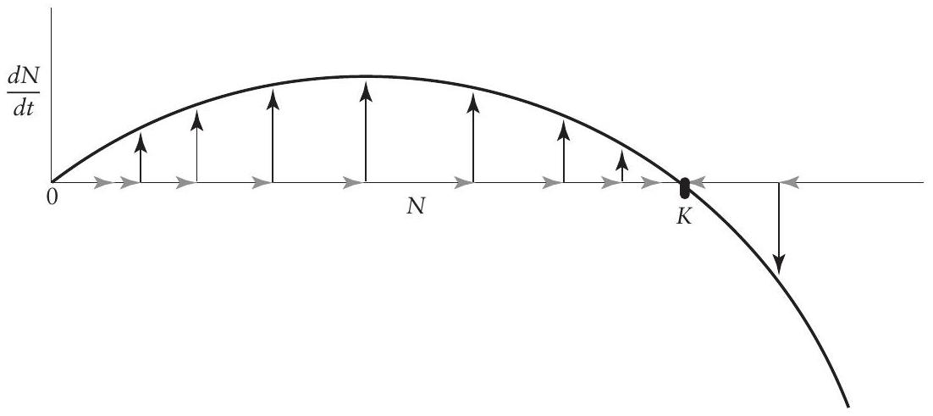
FIGURE 4.12. Dynamics of the logistic equation in one dimension, with the changes in the derivative graphed as the ordinate.
librium point. For example, consider the equilibrium point at the carrying capacity $(K)$. The slope of the curve at that point is simply the derivative with respect to $N$ of the derivative with respect to time, evaluated at $K$, or
$$\frac{d\left(\frac{dN}{dt}\right)}{dN}=r−\frac{2rN}{K}.$$
Substituting $K$ for $N$ (because the slope is the derivative evaluated at $K$ ), we obtain
$${\left.\frac{d\left(\frac{dN}{dt}\right)}{dN}\right|}_{N=K}=r−\frac{2rK}{K}=r−2r=−r.$$
which tells us, first, that the point $K$ is an attractor (because the eigenvalue, $−r$, is negative) and second, that the rate of approach to that equilibrium will be $−r$. A similar procedure applied at the other equilibrium point ( 0 ) gives an eigenvalue of $r$, showing that it is a repeller (because $r$ is positive) and that the rate of deviation from it is $r$.
Note that the eigenvalues computed for the projection matrices of the previous chapter have precisely the same qualitative meaning as in the present chapter. However, earlier we discussed only the computation of eigenvalues for a matrix with constant values, in which case the population was always an exponential population with a single equilibrium point at zero. If the population was growing, its largest eigenvalue was positive and it was growing at a rate equal to the value of that eigenvalue. A negative dominant (largest) eigenvalue indicated, as it does here, that the equilibrium point is an attractor, which means that the population is declining, and the rate of that decline is the value of that eigenvalue. So we see that the dominant eigenvalue of a projection matrix (without density dependence) is precisely the same as the eigenvalue of the exponential equation, $r$.
In two or more dimensions (i.e., when we have two or more species interacting, so two or more state variables), the situation is a bit more complicated. In two dimensions the state space is the plane, and we must examine the dynamics of the system in that plane in a third dimension. We have already looked at this issue in a very qualitative way in figure 4.4 (the first two panels, representing the stationary beaker), where the fixed magnet either attracted or repelled the falling magnet. We now examine the two-dimensional case in more detail. Consider the physical model in figure 4.13. A marble rolling on this surface will eventually wind up at the point where the two folds intersect, but there will be a bias in that most of the time it will roll down along the fold labeled A. It would be possible for it to roll directly down fold B and arrive at the equilibrium point, but this would be very unlikely because that fold is a knife edge on which the marble would have to balance as it rolled down.
For heuristic purposes it makes sense to ask what would happen if the marble began exactly on the fold A. Now we can represent the system in a single dimension, a dimension along fold A , and look at the dynamics along
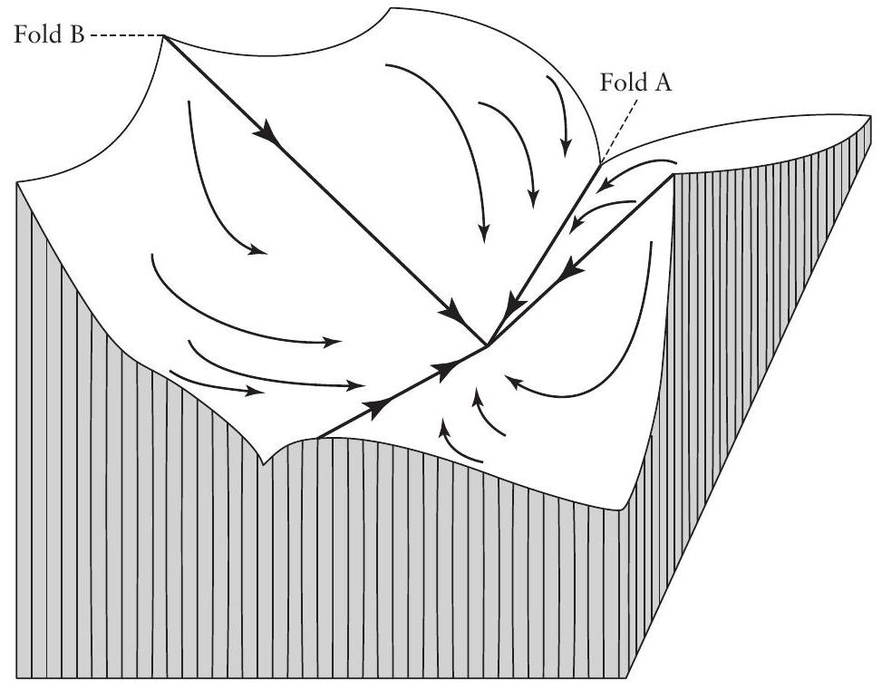
FIGURE 4.13. Physical model of the dynamics of a point attractor in two dimensions.
this fold as if it were a one-dimensional system. Thus the analysis reverts exactly to the one-dimensional analysis we did in figures 4.9-4.12 above. And indeed the rate of change of the rate of change along this fold is an eigenvalue.
But there is still the theoretical possibility that the marble will balance on fold B and, like a tightrope walker, roll down, precariously balanced, until it reaches the equilibrium point. As unlikely as that may seem, we can still analyze it mathematically using the graphical method we used in figures 4.94.12. Again we come up with a measure of the rate of change of the rate of change as we approach the equilibrium point, and that rate is an eigenvalue. Thus we see how, when we have two dimensions, we have two eigenvalues. Indeed it is the case that there will always be as many eigenvalues as there are dimensions in the system.
Here we see the significance of the "dominant" eigenvalue. It is the value of the rate of change of the rate of change along the dominant fold (fold A in figure 4.13), that is, the rate at which the system will approach the equilibrium point as it gets close to it. There will always be one collection of points (a "fold") along which the marble will eventually tend, and that collection of points defines the one-dimensional system that is used to calculate the dominant eigenvalue (see figures 4.9 and 4.10).
In figure 4.14 the three possible configurations in two dimensions are illustrated, along with the eigenvalue states, a point attractor when both eigenvalues are negative, a point repeller when all the eigenvalues are positive, and a "saddle" point when one eigenvalue is negative and the other positive. Clearly, an examination of the signs of the eigenvalues provides a definitive statement as to which of the situations exists. Two positive eigenvalues indicate a simple
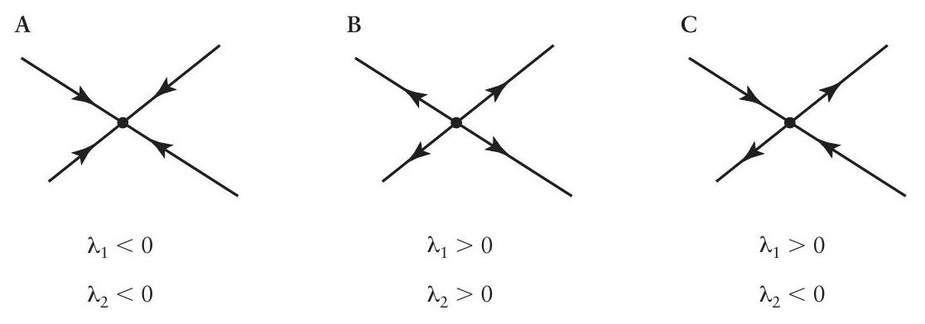
FIGURE 4.14. Conditions of eigenvalues for the three most common qualitatively distinct arrangements in two dimensions. (A) Point attractor. (B) Point repeller. (C) Saddle point repeller.
point repeller, two negative eigenvalues indicate a simple point attractor, and a positive and a negative eigenvalue indicate a different kind of repeller. Note that in the latter case the point is approached from some lines and repelled along other lines, much as a marble would be when rolling along the surface of a saddle. For this reason, this sort of equilibrium is referred to as a saddle point repeller.
So far our presentation has been largely graphical and heuristic. In reality, for a given model simple recipes exist for finding the eigenvalues of a system at a point (indeed, in the contemporary world a few keystrokes or pointing and clicking on the "find eigenvalue" button is usually the way to do it). Frequently the eigenvalues turn out to be simple real numbers and one merely has to compare them to zero to determine the qualitative nature of the point. But sometimes they turn out to be complex numbers, that is,
$$λ=r+ci,$$
where $i$ is the square root of -1 . Thus there is a real part $(r)$ and an imaginary part (c). There is no convenient way of explaining exactly why, but the fact is that oscillatory systems (e.g., the swirling beaker model of figure $4.4C,D)$ have eigenvalues with nonzero imaginary parts. The parallel graphs of the ones already made in figure 4.14 are shown in figure 4.15 for oscilla-
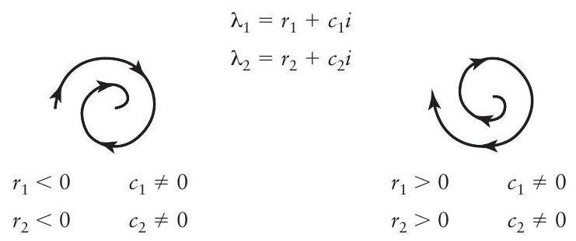
FIGURE 4.15. Conditions of eigenvalues for the two most common qualitatively distinct arrangements in two dimensions when the eigenvalues have nonzero imaginary parts.
tory point attractors and repellers. It is a simple rule that nonzero imaginary parts of the eigenvalues mean that the system is oscillatory, and the oscillations wind down to the equilibrium point if the real values are negative and wind away from the point if the real values are positive.
EXERCISES
4.10 In chapter 1 (exercise 1.17) you used the logistic map to project the population 50 times with values of $λ=1.5,2.0,3.0$, and 3.5 . Do the same for $λ=3.4,3.5,3.56$, 3.565 , and 3.567 , starting with 0.8 individuals and projecting 100 time steps. Note that at the end of the run the numbers tend to repeat themselves in a regular sequence. For example, for $λ=3.4$ the numbers go from 0.452 to 0.842 and then back again to 0.452 , which is to say that there is a two-point cycle. How many points are in the cycles at the ends of the runs of the other values of $λ$ ? Plot the numbers in a particular cycle versus the value of $λ$ that gave those numbers.
4.11 Add to the graph of 4.10 the cycles for $λ=3.43,3.455$, and 3.53 .
4.12 Add to the graph of 4.11 the cycle (approximate cycle) for $λ=3.6$.
Basic Concepts of Equilibrium and Stability in One-Dimensional Maps
So far we have focused on models in continuous time and, although we didn't show them explicitly, these are based on differential equations. Although the same basic dynamical concepts apply to models in discrete time using difference equations, the development and rules are actually quite different. Let us suppose that a reasonable model of population dynamics is a mapping from one time period to the next, which is to say that the population density at this point in time is some multiple of what it was in the previous time period. That is, if $N_{t}$ is the population density at time $t$, we have, for example,
$$N_{t+1}=λN_{t},$$
where $λ$ is, at this point, an arbitrary constant. This is an alternative way of expressing the exponential growth of a population. The relationship between this form and the differential equation form of chapter 1 is as follows. From the equation
$$\frac{dN}{dt}=rN$$
integrate to obtain
$$N_{t}=N_{0}e^{rt}$$
which means we can also write
$$N_{t+1}=N_{0}e^{r(t+1)}=N_{0}e^{rt}e^{r}.$$
Substituting from equation 2, we have
$$N_{t+1}=N_{t}e^{r}$$
and letting $λ=e^{r}$ we substitute to obtain equation 1 , making it obvious that the one-dimensional map is exactly equivalent to the more traditional differential equation. Recall from chapter 1 that we began with the discrete form and derived the continuous form. Here we just do the reverse.
The One-Dimensional Map
The one-dimensional map (one-dimensional because only one dynamic state variable is under consideration) is a convenient modeling technique, especially because of its obvious graphical interpretation: it is possible to rapidly gain an idea of the dynamic behavior of a model simply by glancing at a graph. A one-dimensional map applies to those systems that can be represented as the projection of a variable from one time unit to the next. First construct a graph of the population density in year $t+1$ versus the population density in year $t$. Suppose, for example, that the population density beginning in year 1997 is 10 and in subsequent years it is 20 , then 40 , then 80 , then 100 , then 110. That is, $N_{1997}=10,N_{1998}=20,N_{1999}=40$, etc. To graph the numbers in the style of a one-dimensional map we first graph 10 on the abscissa and 40 on the ordinate, then 40 on the abscissa and 80 on the ordinate, then 80 on the abscissa and 100 on the ordinate. In doing so we are essentially making a graphic form of the number series $20,40,80,100,110$. We know that the number 20 projects into 40 , and drawing a vertical arrow from 20 on the abscissa to the intersection of a horizontal arrow from the value of 40 on the ordinate is simply a graphic statement of this fact (that 20 projects into 40 ). We now wish to project from 40 , in which case we simply draw a similar arrow from 40 on the abscissa to the point where it intersects the value of 80 on the abscissa. The first projection (from 20) yielded 40, and we sought to initiate the second projection from this value of 40 . This is a general rule. The next projection always begins where the previous projection left off. How can we know where that initiation is? We can obviously simply search for the ordinate value on the abscissa (i.e., after the first projection from 20 to 40, we search for 40 on the abscissa so as to make the second projection). But that search is made graphically much simpler if we draw a reference line beginning at zero for both abscissa and ordinate and rising at a 45 degree angle to the axes. This enables us to take the original projection and reflect it back to the 45 degree line. It is simply a graphic technique for locating the projected value on the abscissa so that it can be projected into the next time period. This whole example is illustrated in figure 4.16.
This simple example can now be generalized. Instead of using specific numbers, we may write a general rule of projection. For example, $N$ at time $t$ will become $N+5$ at time $t+1\left(N_{t+1}=N_{t}+5\right)$, or $N$ next year will be twice the value of $N$ this year $\left(N_{t+1}=2N_{t}\right)$, or $N$ next year depends on the value of $N$ this year, that is, $N$ next year is a function of $N$ this year $\left(N_{t+1}=f\left(N_{t}\right)\right)$. Although it is frequently possible to state the exact relationship between $N$ this year and $N$ next year, in the absence of that knowledge it is also useful simply to be able to draw the general shape of $f$, which is frequently pos-
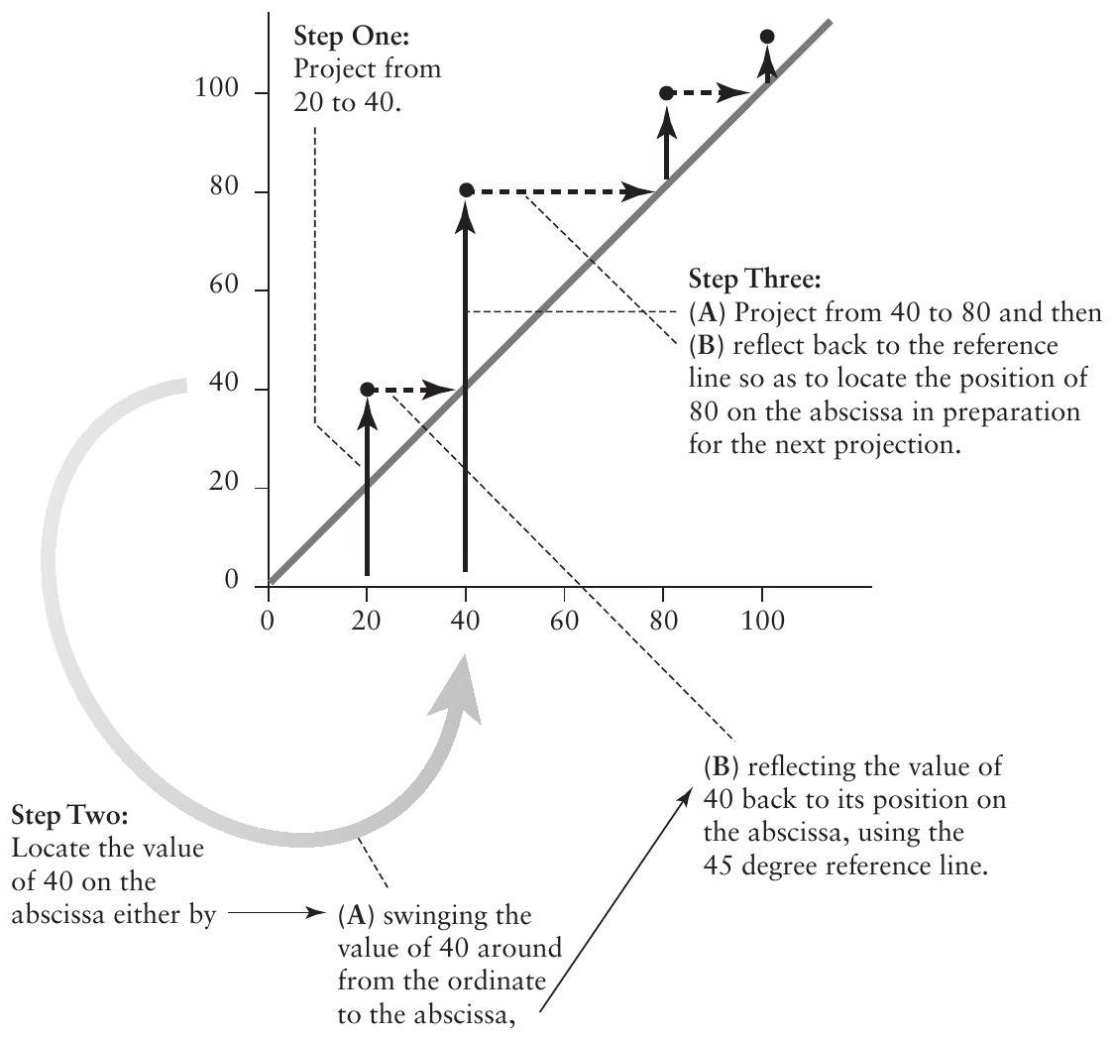
FIGURE 4.16. Step-by-step illustration of the process of stair-stepping using numerical values for a one-dimensional map.
sible only from qualitative knowledge of how the system behaves. But the stair-stepping procedure is still the same. Instead of projecting from 20 to 40 (as in the above example), project from an arbitrary starting point on the abscissa to the graph of the function. Then locate that projected value on the abscissa by reflecting it back to the 45 degree reference line and project it to the graph of the function again. This process is illustrated in figure 4.17.
The general rule, which is then repeatedly iterated, is project to the function, reflect to the reference line, project to the function, reflect to the reference line, and so on. After a short practice session, the general qualitative dynamics of almost any one-dimensional map can be rapidly visualized with a simple glance at the graph.
In figure 4.18, equation 1 is graphed along with the classical stair-stepping technique that can be used to quickly visualize the dynamics of the system. Where the graph of the equation crosses the 45 degree line, an equilibrium point exists. For equation 1 (the exponential equation), that equilibrium is at zero. If $λ>1.0$, the particular nature of that equilibrium is unstable, because any value of $N$ close to the point (i.e., the equilibrium $N=0$ ) will deviate away from it. If the point were set at exactly $N=0$, a glance at equation 1
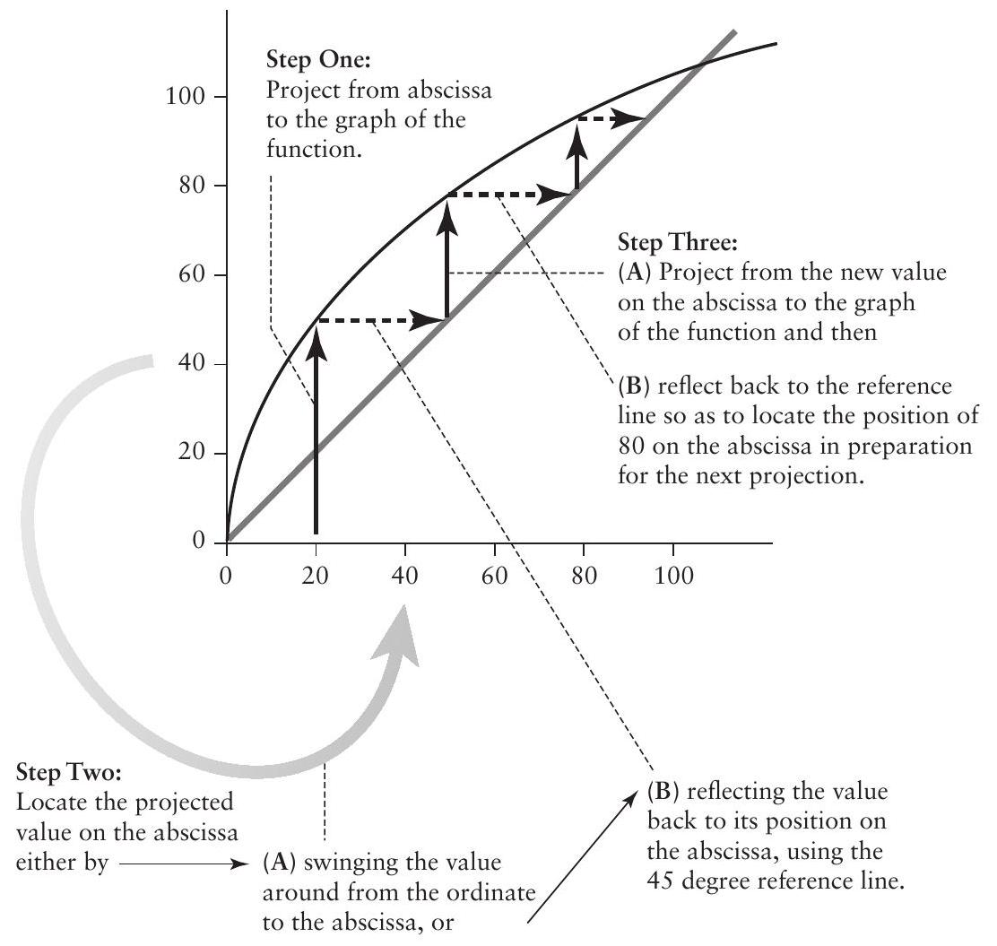
FIGURE 4.17. Step-by-step projection using a function rather than numerical values.
shows that it would stay there forever. But the slightest increase from zero (e.g., $N=0.0000001$ ) means that the population will grow and thus deviate from the equilibrium point.
Now suppose that at each time interval a constant number of individuals migrates into the population. Suppose that the number is $m$, thus transforming equation 1 into
$$N_{t+1}=λN_{t}+m.$$
A graph of equation 3 is presented in figure 4.19 (assuming that $λ<1.0$ ). Once again the point at which the graph of the equation crosses the 45 degree line is an equilibrium point (setting $N$ at exactly that point, which in this case is $m/(1−λ)$, results in the same value of $N$ for every future time period). This time, however, the equilibrium is a stable one, as illustrated in figure 4.19. Whatever the initial population size, the tendency will be to return to the value of $m/(1−λ)$, the equilibrium state, which is thus an attractor.
Now assume that, instead of there being regular immigrants into the population, a predator population exists in the habitat, and that predator
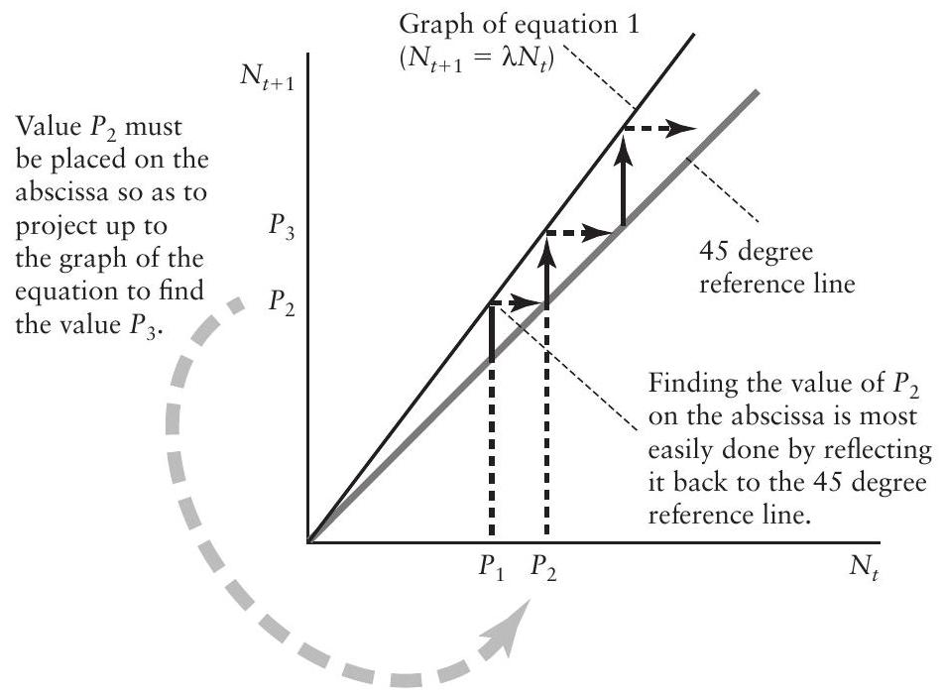
FIGURE 4.18. Exponential equation presented as a one-dimensional graph. The qualitative dynamics of such a system are easily visualized with the stair-stepping technique. Beginning at point $P_{1}$, go up to the graph of the equation to reach $P_{2}$ on the ordinate. The ordinate value $P_{2}$ must then be positioned on the abscissa, which is most easily done by reflecting it to the 45 degree reference line (dashed arrow), which indicates its position on the abscissa. From $P_{2}$ on the abscissa, go up to $P_{3}$ and repeat the process (see figures 4.16 and 4.17).
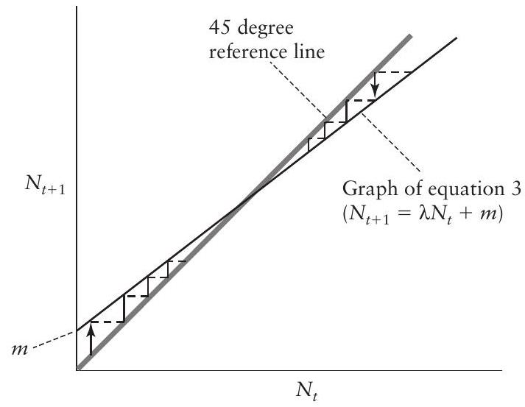
FIGURE 4.19. Graph of equation 3, illustrating a point attractor. The stair-stepping technique is the same as in figures 4.17 and 4.18. Any initiating point either above or below the attractor (where the graph of the function crosses the 45 degree reference line) eventually approaches that point. It is thus a point attractor, because any deviation from it will automatically revert to it.
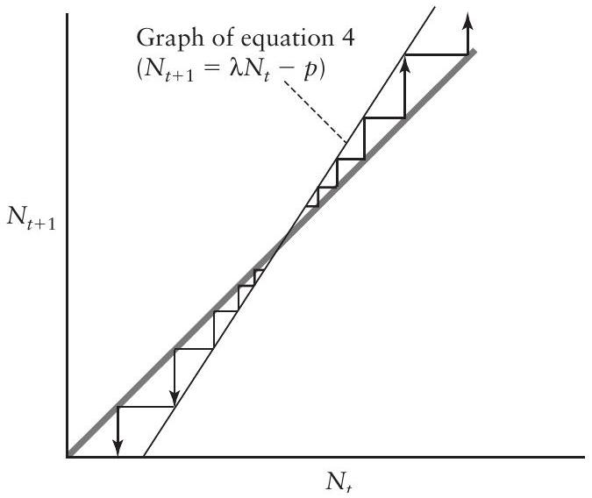
FIGURE 4.20. Graph of equation 4, illustrating an unstable equilibrium. The stair-stepping technique is the same as in figures $4.17,4.18$, and 4.19. Any point deviating only slightly from the equilibrium will continue deviating. It is thus a point repeller, because any deviation from it will continue deviating (it "repels" all values).
population does not change as a function of the prey density. Thus a constant number, $p$, of individual prey organisms will be taken out of the population in each time unit, and the appropriate equation is
$$N_{t+1}=λN_{t}−p,$$
which is graphed in figure 4.20 (with the assumption that $λ>1.0$ ). Note that the equilibrium point is $p/(λ−1)$, and it is an unstable one, making the point a repeller, just as the zero equilibrium point was unstable for the original exponential equation (equation 1 ).
These two simple modifications to the basic exponential equation are both linear. However, most ecological processes of interest are known to be nonlinear, so it makes sense to modify equation 1 in a nonlinear fashion, too. The most elementary nonlinearity would be to assume that the parameter that multiplies the variable of interest (i.e., $λ$ in equations 1,3 , and 4 ) is itself a function of the variable. If we assume that the parameter $λ$ is a decreasing function of $N$ (i.e., that the growth of the population depends on its densityrecall density dependence from chapter 1) and furthermore that the exact function is $λ−λN$ (i.e., the $λ$ in equations 1,3 , and 4 becomes $λ−λN$ ), the exponential equation (equation 1 ) becomes
$$N_{t+1}=λN_{t}\left(1−N_{t}\right).$$
In figure 4.21, equation 5 is graphed for two different values of $λ$. From the simple stair-stepping graphic technique it is obvious that both cases pictured are oscillatory. That is, at successive intervals the population alternately increases and decreases, as illustrated in the diagrams beneath the stair-stepped graphs. The difference between figure 4.21A and 4.21B is the difference between an oscillatory attractor (figure 4.21A) and an oscillatory repeller (figure 4.21B).
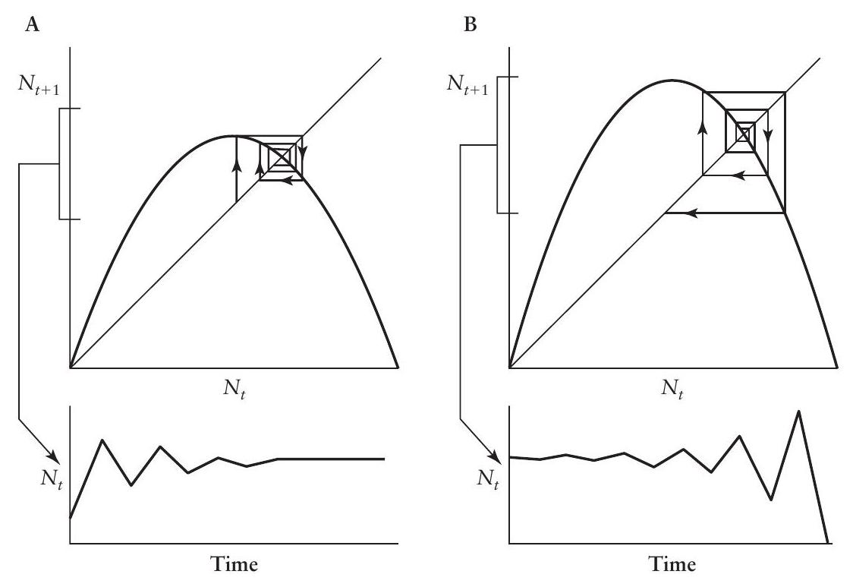
FIGURE 4.21. Graphs of equation 5. (A) Oscillatory attractor. (B) Oscillatory repeller. In both A and B the graph below the main graph illustrates the behavior of the variable through time.
EXERCISES
4.13 Graph $N_{t+1}$ versus $N_{t}$ for the logistic map for $λ=3.4,3.5,3.56$, and 3.6. Print out your graphs and make a pencil-and-paper stair-step diagram illustrating the dynamics of each graph. Compare these dynamics to those for the equivalent values of $λ$ from exercises 4.10, 4.11, and 4.12.
4.14 The Ricker map is given generally as
$$N_{t+1}=λN_{t}e^{1−bN_{t}}.$$
Plot $N_{t+1}$ versus $N_{t}$ for $λ=6,5,4$, and 3 with corresponding $b=2,3,4$, and 5 . Print out your graphs and make a pencil-and-paper stair-step diagram illustrating the dynamics of each graph.
4.15 Set up an Excel sheet to generate a logistic map with $λ=4$. The first step should look like this:
$$◯$$ | A
1 | N
2 | 0.1000
3 | $$=4^{∗} A2∗∗(1−A2)$$
4 | 0.9216
5 | 0.2890
6 | 0.8219
7 | 0.5854
8 | 0.9708
9 | 0.1133
10 | 0.4020
11 | 0.9616
12 | n 1478

Now set up a second column that simply reproduces the first one. Your sheet should look like this:
$$◯$$ | A |  | B
1 | N |  | $$N^{′}$$
2 |  | 0.1000 |  | 0.1000
3 |  | 0.3600 | $$=4∗B2∗(1−B2)$$
4 |  | 0.9216 |  | 0.9216
5 |  | 0.2890 |  | 0.2890
6 |  | 0.8219 |  | 0.8219
7 |  | 0.5854 |  | 0.5854
8 |  | 0.9708 |  | 0.9708
9 |  | 0.1133 |  | 0.1133
10 |  | 0.4020 |  | 0.4020
11 |  | 0.9616 |  | 0.9616
12 |  | 0.1478 |  | 0.1478
13 |  | 0.5039 |  | 0.5039
14 |  | 0.9999 |  | 0.9999

Now plot column A (labeled $N$ ) against $N^{′}$, which, of course, will yield a graph of all the points on the 45 degree line. Now take the sixth entry, which is equal to 0.5854 , and retype it into the sixth position in column B (labeled $N^{′}$ ) (i.e., in place of the formula, directly type 0.5854$)$. What happens to the graph? Why?
4.16 Modify the logistic map by subtracting a constant number (recall exercise 4.9), as might be done by a naïve manager. Let $λ=3.5$, and subtract 0.25 individuals at each time step. Create a plot of $N_{t+1}$ versus $N_{t}$ and project the population 50 time units. Repeat for $λ=4$, then for $λ=4.55$.
4.17 For the modified logistic map of exercise 4.16 , set $λ=4.556$ and iterate over 200 time periods, beginning with an initial population of 0.3 and graph the time series (be sure to force your graph from 0 to 1 ).
Figures 4.19-4.21 summarize the classical notions of equilibrium and stability in one-dimensional maps. A single point is the equilibrium point, and it may be an attractor (stable) or a repeller (unstable), oscillatory or nonoscillatory. Because we are now dealing with discrete space rather than continuous space, the eigenvalue rules as elucidated in the previous section do not directly apply. The eigenvalue here is the slope of the function as it crosses the 45 degree line, with dynamics as summarized in figure 4.22 , where it should be evident that an eigenvalue greater or less than 1 or -1 stipulates the qualitative nature of the equilibrium point. If the eigenvalue is $>1$ the system is a point repeller. If the eigenvalue is $<1$ but $>0$ the system is a point attractor. If the eigenvalue is $<0$ but $>−1$ the system is an oscillatory attractor. If the eigenvalue is $<−1$ the system is an oscillatory repeller.
If the system generates a strange attractor (or, for that matter, a permanent cycle), ideas of point attractors and repellers are useless, despite the fact that point repellers are always contained within strange attractors. For example, in figure 4.23 three cases are illustrated in which the critical equilibrium point (where the graph of the equation crosses the 45 degree line) is a repeller. However, knowing that the equilibrium point is a repeller provides us with scant information on what is interesting about the behavior of the system. Indeed, what is important in this case is the distinction between A and B on the one
Point Repeller | Point Attractor | Oscillatory Attractor | Oscillatory Repeller
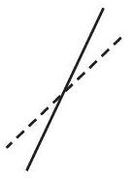 | 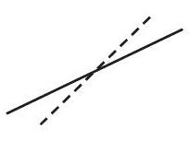 | 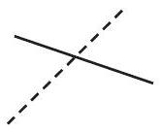 | 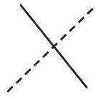
$$λ>1$$ | $$1>λ>0$$ | $$0>λ>−1$$ | $$λ<−1$$

FIGURE 4.22. Eigenvalue values for the various forms of stability in a onedimensional map. The dotted line is the 45 degree reference line, and the solid line is the function (illustrating that part of the function near to its crossing with the 45 degree line).
hand and C on the other. Cases A and B will persist indefinitely (i.e., are sustainable), whereas in case $C$ the variable is extinguished from the system (the population goes locally extinct). If this were, for example, the population of an introduced natural enemy in an agroecosystem, we would care little that the population is theoretically unstable (i.e., its equilibrium point is unstable). Rather we would be concerned with whether the new natural enemy would persist in the environment, that is, whether we were dealing with, on the one hand, the situation in figure 4.23 A or B or, on the other hand, with the situation in figure 4.23 C . Our interest here would be not in the equilibrium point itself but in the limits, or boundaries, of the system. These boundaries are illustrated by dashed lines intersecting the two axes in figure 4.23 A and B .
A further word is in order regarding the difference between the patterns in figure 4.23 A and B. Figure 4.23 A is classically known as an $n$-point cycle (the particular value of $n$ in figure 4.23 A is 2 , because there are two actual values of $N$ that repeat themselves forever, as indicated by the dashed lines crossing the axes). It is the one-dimensional equivalent of the classical limit cycle
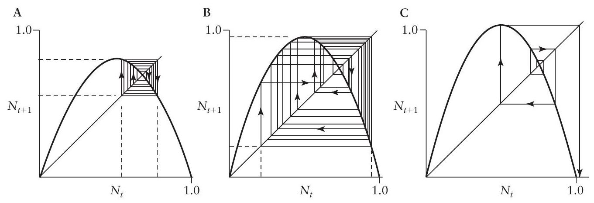
FIGURE 4.23. Graphs of equation 5. (A) A two-point periodic attractor $(λ=3.1)$. ( B ) A strange attractor $(λ=3.8)$. (C) An oscillatory repeller, leading to extinction of the population $(λ=4.2)$. In cases A and B the population has a repeller (is unstable) where the function graph crosses the 45 degree line, but in both cases the repeller is constrained by dynamic boundaries. Cases A and B are thus referred to as regionally stable.
in the context of differential equations. Figure 4.23B represents an example of chaos, better termed a strange attractor. The equilibrium point is unstable, yet there is no single $n$-point cycle, and trajectories generally move in a totally unpredictable direction, giving rise to the popular appellation chaos. An enormous literature is devoted to the analysis and significance of the difference between the pattern in figure 4.23A and that in 4.23B (e.g., Ellner and Turchin 1995; Hastings et al. 1993). To some extent that literature has been misdirected. The key question seems to have become whether ecological systems are chaotic. But to understand ecological systems it is not clear how knowing whether a system is chaotic or has a 50 -point cycle will make much of a difference! True, a chaotic system is in theory unpredictable, but in practical fact an $n$-point cycle is just about as unpredictable if $n$ is relatively large. On the other hand, in both figure 4.23A and figure 4.23B there are clear structures to the trajectories. Both are fundamentally oscillatory, even though the peaks of the oscillations do not repeat themselves exactly each year in the case of 4.23 B and, most importantly, both have limits that they will never transcend (in a strictly deterministic world).
These limits are essentially identical to what Lewontin (1969) has referred to as dynamic boundedness. They define a section of the state space into which all nearby trajectories will eventually enter but that no trajectory can ever exit. Because all nearby trajectories must enter this space, the space itself is called an attractor, even though the equilibrium point within that space is unstable. Whether an attractor is strange or periodic will not be an important focus of the rest of this chapter. The significant practical feature for understanding ecosystem dynamics is the location of the boundaries and the qualitative structure of the dynamics, for both periodic and strange attractors (and repellers). Thus the important question to be asked of an unstable point is whether the nonlinearities of the system create boundaries around that point, thus making it either a periodic or a strange attractor. If not, the system will extinguish itself.
Stability and Equilibrium in the Logistic Map
The logistic map (as equation 5 is usually called), can be used to illustrate these and other simple ideas in a straightforward manner. The equilibrium point is
$$N^{∗}=(λ−1)/λ$$
(there is another, trivial, equilibrium point at $N^{∗}=0$ ). This means that $λ$ must be greater than 1.0 to have a positive equilibrium point, and the equilibrium will be stable and nonoscillatory whenever the derivative of the function, evaluated at the equilibrium point, is greater than 0 (these conditions, and the ones that follow, should be clear after a detailed examination of the graph of equation 5 in figure 4.21; note especially that here the parameter $λ$ is not equal to the eigenvalue, as it was in the case of the exponential equation). That is, differentiating equation 5 , we obtain
$$\left(dN_{t+1}/dN_{t}\right)=λ−2λN_{t},$$
which, when evaluated at the equilibrium point (i.e., substitute $\left.N_{t}=(λ−1)/λ\right)$, is
$$\left(dN_{t+1}/dN_{t}\right)=λ−2λ[(λ−1)/λ]=λ−2λ+2=2−λ,$$
in which case we see that as long as $λ<2$ the equilibrium point will be a simple nonoscillatory attractor (note that the case of an unstable nonoscillatory point, as shown in figure 4.20 , is not possible with this model). When $λ>2$, the system will be oscillatory. It will have an attractor if the derivative of the function evaluated at the equilibrium point is greater than -1 . Thus
$$2−λ>−1$$
or
$$2<λ<3$$
indicates an oscillatory attractor, and
$$2−λ<−1$$
or
$$λ>3$$
indicates an oscillatory repeller. Note that the value of the eigenvalue is $2−λ$, making these observations consistent with the eigenvalue conditions of figure 4.22.
The existence of an oscillatory repeller when $λ>3$ leads to the further question of how to distinguish between persistence (cases A and B of figure 4.23 ) versus extinction (case $C$ of figure 4.23). Extinction will occur when the projection from the maximum value of the map falls on the $x$-axis at a point greater than the intersection of the function (see figure 4.24).
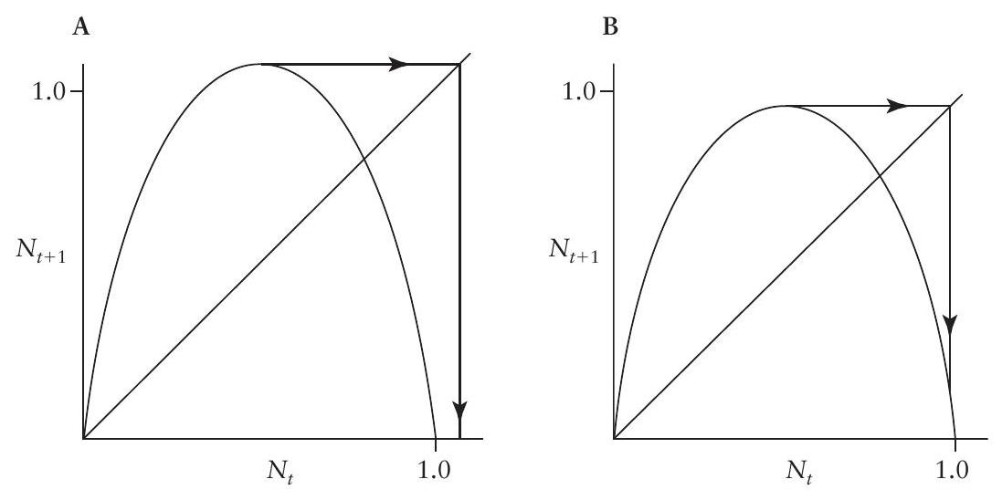
FIGURE 4.24. The difference between stability and instability in the regional sense. (A) Regionally unstable, the population will go extinct. (B) Regionally stable, the population will persist (albeit in a chaotic state). In both cases, the equilibrium point is unstable in the neighborhood sense.
From an examination of the logistic map (equation 5) we see that the function intersects the abscissa at 0 and 1 . Thus extinction of the system will occur when the projection from the peak of the map touches the $x$-axis at a point greater than 1 (see figure 4.24 A ). The peak occurs at $N_{t}=0.5$, so its projection (from equation 2) will be
$$N_{t+1}=λ(0.5)(1−0.5)=0.25λ,$$
and the condition for extinction is thus
$$\begin{matrix} & 0.25λ>1, \\ & λ>4.\end{matrix}$$
When we combine this information with the earlier observation that the system will have an oscillatory (either periodic or strange) attractor whenever
$$3<λ<4,$$
we can say that the system will be sustainable as long as $λ$ is between 1 and 4 , even though the classic conditions for stability fail for $λ>3$. Although the specific development in this chapter is associated with the density of a single population, the same dynamic rules apply if the state variable is some other interesting variable. For example, $N$ might be the yearly production of manure from a dairy farm or the soil organic matter in a forest system or so forth. If we presume that equation 5 represents the system, we can unambiguously define sustainability as $1<λ<4$. The trick, of course, is that equation 5 is normally too simple to accurately represent anything as complicated as organic matter or manure (or even population density), and we use it here for didactic purposes only.
The upper and lower boundaries of the system are easily calculated. The upper limit is simply the peak of the function
$$N_{t+1}=λ(0.5)(1−0.5)=0.25λ,$$
and its projection,
$$N_{t+1}=λ(0.25λ)(1−0.25λ)=0.25λ^{2}−0.0625λ^{3},$$
is the lower limit. Again, depending on the context, such boundaries may be of tremendous interest. For example, if $N$ is the population density of a pest insect and the damage threshold is known (say it is $D$ ), the population will never be a pest if $0.25λ$ (the upper threshold) is less than $D$. Thus $λ<4D$ exactly stipulates the conditions under which this population will be an occasional pest.
Basins of Attraction in the Logistic Map
For most simple models of ecological processes it has been possible to simply analyze the equilibrium point(s) and leave it at that. Most ecologists now admit that more complicated models are necessary to reflect even the simplest ecological phenomena. With even slightly more complex models we face a sit-
uation in which alternative equilibria exist in the same model. For example, if we combine the ecological principle that led to equation 4 with that which led to equation 5 , we obtain
$$N_{t+1}=λN_{t}\left(1−N_{t}\right)−p\text{ for }N_{t}>0,$$
where $λ$ is again the rate of population increase and $p$ is the number of individuals removed from the population during each time unit by a constant predator. To make equation 6a relevant to ecological processes, we restrict its application to $N_{t}>0$ and add the equation
$$N_{t+1}=0\text{ for }N<0.$$
This condition simply acknowledges that there can be no values of $N$ less than zero (assuming the running example of $N$ signifying the population density of an insect pest; other variables may take on negative values, in which case the special condition for $N<0$ would not be necessary). Equation 6 is graphed in figure 4.25. There are three equilibrium points, given as
$$N^{∗}=0\text{ (from equation 6b), }$$
$$N^{∗}=[(λ−1)/2λ]+{\left\{[(λ−1)/2λ]^{2}−p/λ\right\}}^{1/2},$$
and
$$N^{∗}=[(λ−1)/2λ]−{\left\{[(λ−1)/2λ]^{2}−p/λ\right\}}^{1/2}.$$
Inspecting figure 4.25, we see that the central equilibrium point is a repeller and the lower one (at $N=0$ ) is an attractor, as is the upper one. Although
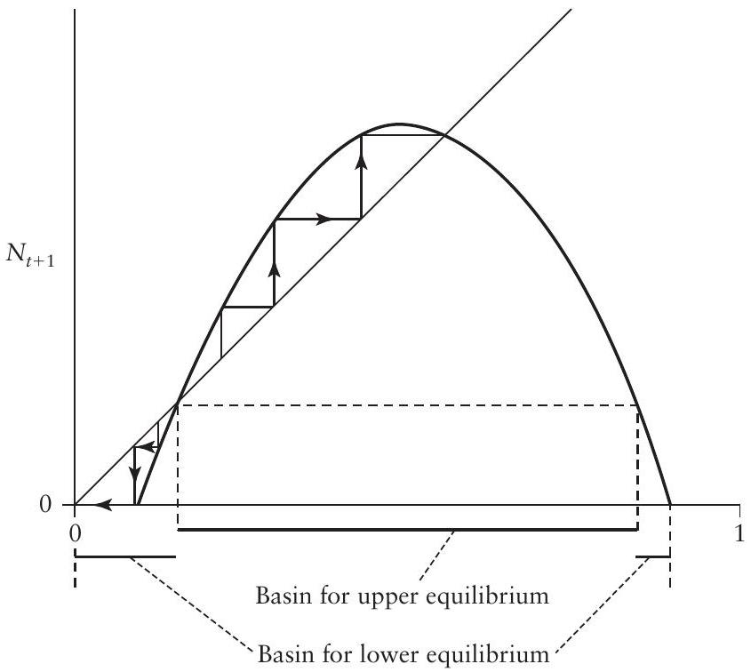
FIGURE 4.25. Graph of equation 6, illustrating the two basins of attraction for the two point attractors.
knowing the locations of the equilibrium points is important, another feature of figure 4.25 is important to understand the population dynamics. Any value of $N$ near to but greater than the repeller will eventually approach the upper attractor, whereas any point less than the repeller will eventually approach the lower attractor. The repeller thus separates the state space (all possible values of $N$ ) into those values that approach the upper attractor and those values that approach the lower attractor (this is only approximately true, as discussed in the next paragraph). The unstable point in this context is referred to as a separatrix, and the collection of points on either side of it is a basin of attraction. The basin of attraction refers to the section of the relevant state space in which all trajectories approach a given attractor. This question of which of the initial values will eventually reside in particular locations in the state space may turn out to be far more important for analyzing ecosystems than is the traditional question of the exact location of the equilibrium point and whether it is stable (see, for example, Scheffer et al. 2009).
This issue is a bit more complicated in the case of the logistic map when the value of $λ$ is very large. Very high values of $N$, because of the strong density dependence of the logistic model, will be projected to values of $N$ less than the separatrix. Thus there is a section of the lower equilibrium's basin of attraction that exists at very high values of $N$, in addition to the obvious one that exists at lower values of $N$, as discussed later.
EXERCISES
4.18 Generate a time series using the formula for density-dependent population growth of Bleasdale and Nelder (1960) and Hassell (1975),
$$N_{t+1}=\frac{λN_{t}}{1+N_{t}^{b}},$$
setting $λ=5$ and $b=4$ and reiterating for 50 time units. Create a graph of the function from the equation, and experiment with other values of $λ$ and $b$ (in the spreadsheet, fix $λ$ and $b$ separately, then generate both the function graph and the time series).
4.19 Repeat exercise 4.18 but with $λ=1$ and $b=1$. Experiment with a variety of values of $b$. What do you conclude about the qualitative behavior of the model with respect to variation in the parameter $b$ (try $b=1,1.5$, and 0.5 , for example)?
Structural Stability
A notion of stability totally distinct from that discussed so far may arise when parameters undergo change. That is, in all the above examples, the state variable ( $X_{t}$ or $Y_{t}$ or $N_{t}$ ), the one that is dynamic, which is to say the one that varies through time, is clearly distinguished from the parameters, which do not vary through time. For example, in equation $6a,N_{t}$ is the state variable, while $λ$ and $p$ are parameters. For purposes of analysis we presume that $N_{t}$ varies through time, while $λ$ and $p$ do not.
A different sort of analysis emerges when we ask what happens when $λ$ and $p$ themselves vary within a distinct time frame. For example, $N_{t}$ may vary in ecological time while $λ$ changes slowly as evolution forces change in its value, and $p$ may change as the resident predator population slowly increases or decreases. It is of great interest to examine what happens to the general results as the parameters change and what this has to do with stability. Thus "state space" and "parameter space" are quite distinct concepts. State space is represented as a graph of the potential value(s) of the state variable(s) at a given set of parameter values, whereas parameter space is represented as a graph of the potential values of all the parameters in the model.
Consider the case of a nonreproductive population that receives migrants in a density-dependent fashion. That is, suppose that the rate of migration into the population is $f$, but $f$ itself is a negative function of population density (the migrants have the ability to sense when the population is overcrowded, for example, and tend to avoid an overcrowded situation). This circumstance could be modeled with the simple equation
$$N_{t+1}=λ\left(1−N_{t}\right).$$
As illustrated in figure 4.26, if the value of $λ$ is greater than 1.0, the equilibrium point is oscillatory and a repeller (figure 4.26A). If the value of $λ$ is less than 1.0, the equilibrium point is oscillatory and an attractor (figure 4.26C). The question then arises, What if the value of $λ$ is exactly 1.0 ? Such a situation presents precisely the behavior one would expect mathematically: oscillatory and neither an attractor nor a repeller (figure 4.26B).
Although it may not seem particularly important that the population permanently oscillates between two particular values, the form of oscillation is particularly unusual. At every second time projection, the population will return to exactly what it had been before, no matter where it started. For example, if we begin with $N=0.3$, the next value will be 0.7 (see equation 8 ) and the next value 0.3 again, whereas if we begin with 0.2 , the next value will be 0.8 and the following one 0.2 again. That is, the population will oscillate with a cycle that is two time periods in length, but the exact values of the cycle will depend
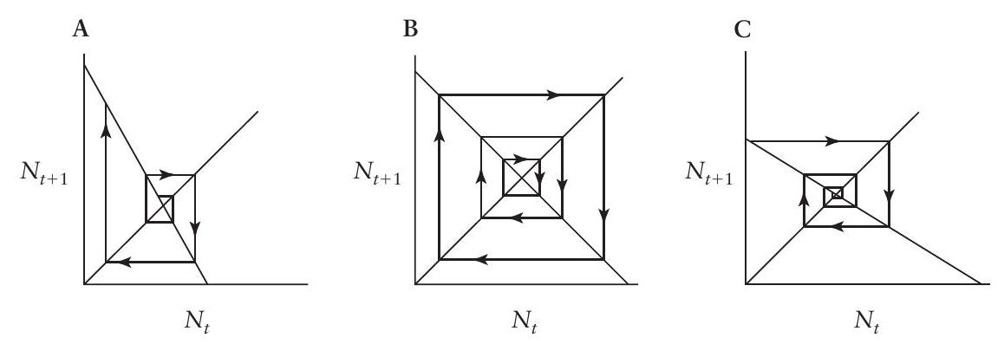
FIGURE 4.26. Illustration of a structurally unstable parameter configuration for equation 8. (A) A point repeller resulting from a slightly larger value of $λ$ than in B. (B) A neutrally stable situation in which the initiation point is forever repeated every other time unit. (C) A point attractor resulting from a slightly smaller value of $λ$.
on the starting point. Although this situation is thought to be uninteresting in a biological sense, it is actually rather important mathematically and is ultimately a key point for conceptualizing the idea of structural stability. The behavior is illustrated in figure 4.26B, in which we see that the oscillations are neither stable nor unstable. This state is dependent on the assumption that $λ=1.0$. If $λ=0.9999$, say, the population will no longer continue returning to the point at which it started but rather will slowly converge on a value of about 0.67 (figure 4.26 C ; actually the value is about 0.66665555 ). That is, the qualitative behavior of the system changes dramatically when the value of $λ$ is changed only slightly, from a system that is dependent on the starting point, ever cycling back to the same point, to a system that converges on a single equilibrium point-an attractor. Similarly, if $λ=1.00001$, the system will slowly oscillate away from the point 0.67 , an oscillatory repeller (figure 4.26 A ). So the value of $λ=1.0$ is a kind of break point for the parameter $λ$. When $λ$ is either greater than or less than 1.0 the system has qualitatively distinct behavior. Points such as $λ=1$ in equation 8 are described as structurally unstable (or the model is structurally unstable at that point) because the slightest change in the parameter will yield a qualitatively distinct form of behavior for the system in general.
Points of structural instability, also called bifurcation points, often occur in ecological models, especially in discrete time, and they play a crucial part in analyzing the overall qualitative behavior of models. For another example, returning to the logistic equation (equation 5), three situations are illustrated in figure 4.27: $λ<2,λ=2.0$, and $λ>2.0$. In the same sense as above, $λ=2.0$ appears to be a structurally unstable situation. The smallest reduction from the value of 2.0 yields a population that asymptotically approaches a point attractor, whereas the smallest increase from the value of 2.0 yields a population that oscillates toward a point attractor. Thus the model is structurally unstable when $λ=2.0$.
Another structurally unstable point is illustrated in figure 4.28. In this case the middle figure (figure 4.28B) is a graph of the logistic with $λ=3.0$. If $λ$ is decreased slightly, the figure in figure 4.28A emerges and the behavior of the
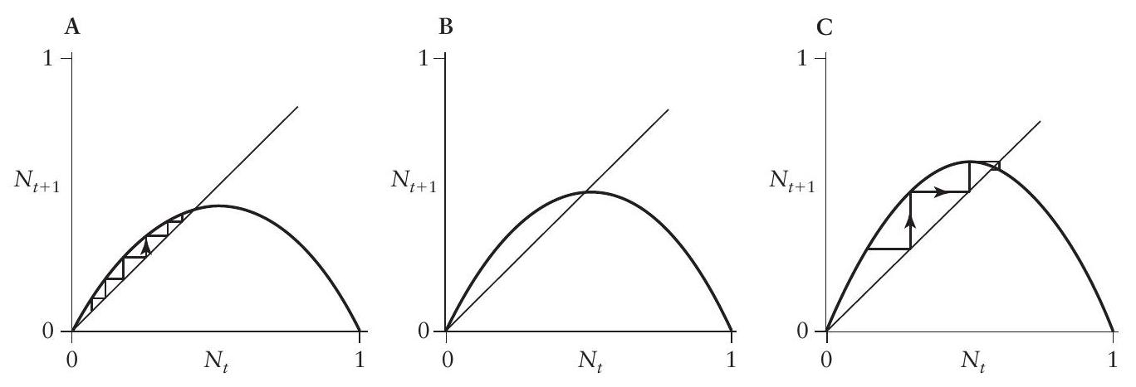
FIGURE 4.27. Graphs of equation 5 (the logistic map), illustrating the structurally unstable configuration obtained when $λ=2.0$. (A) $λ<2.0$, leading to a stable node (nonoscillatory point attractor). (B) $λ=2.0$, the bifurcation point. (C) $λ>2.0$, leading to a stable focus (oscillatory point attractor).
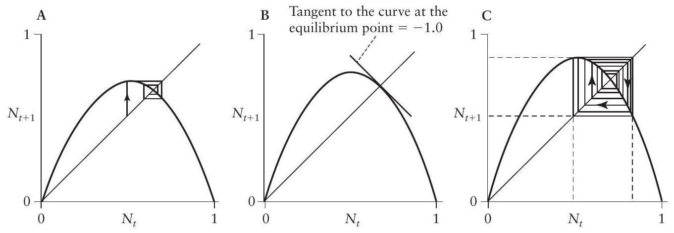
FIGURE 4.28. Graphs of equation 8 (the logistic map), illustrating the structurally unstable configuration obtained when $λ=3.0$. (A) $2.0<λ<3.0$ (see figure 4.27 C ). (B) $λ=3.0$. (C) $λ>3.0$, leading to a two-point attractor.
system is damped oscillations to a point attractor. If $λ$ is increased from 3.0, the figure in figure 4.28 C emerges and the behavior of the system is permanent oscillations with a period of 2 , which is to say that the population, no matter where it is initiated, eventually oscillates forever between two fixed values, indicated with dashed lines in the figure. Again, the model with $λ=3.0$ is structurally unstable in the sense that $λ=3.0$ is a bifurcation point, with qualitative changes in the behavior of the system emerging when the parameter is changed ever so slightly from this value. The system switches from a single stable point attractor (oscillatory) to a stable period-two cycle. This type of bifurcation is known as a period-doubling bifurcation (in the context of continuous systems, i.e., with differential equations, the same qualitative arrangement is known as a Hopf bifurcation).
A very different type of bifurcation may arise in more complicated models. Consider, for example, the case modeled above of a constant population of predators in a system (equations 6 a and 6 b ). With the appropriate choice of parameters, the situation in figure 4.29 may arise. Once again, the center graph
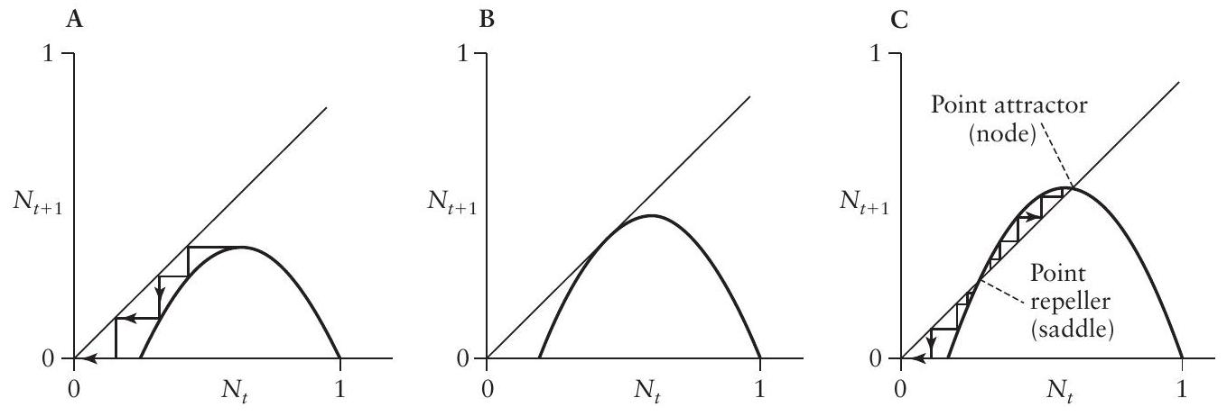
FIGURE 4.29. Illustration of a saddle-node bifurcation. (A) A single attractor at zero. (B) The bifurcation point. (C) After the bifurcation, there is a repeller (saddle) and an attractor (node), indicating that the bifurcation was of the saddle-node type.
(figure 4.29 B ) is a bifurcation point in that one small change in a parameter may create the situation in figure 4.29 A , whereas a change in the other direction might result in the situation illustrated in figure 4.29C. Note that two new equilibrium points have been created (or destroyed) in this bifurcation, one an attractor (sometimes referred to as a node) and one a repeller (sometimes referred to as a saddle). This type of bifurcation is variously referred to as a saddle-node bifurcation or as a blue-sky bifurcation (because two equilibrium points appear "out of the blue").
EXERCISES
4.20 Using the logistic map,
$$N_{t+1}=λN_{t}\left(1−N_{t}\right),$$
solve for the equilibrium value of $N$ and plot the equilibrium value as a function of $λ$.
4.21 Using the modified logistic map with constant predation,
$$N_{t+1}=λN_{t}\left(1−N_{t}\right)−p,$$
solve for the equilibrium value of $N$ and plot the equilibrium values (that's plural) as a function of $λ$. Generate two time series with the model using $λ=3,p=0.3$, starting with $N_{0}=0.3$ and $N_{0}=0.2$. Generate two other time series with the model using $λ=4.4,p=0.3,N_{0}=0.11$, and $N_{0}=0.10$. Compare the time series to what you would have expected from the graph of the equilibrium values as a function of $λ$.
In recent years the saddle-node form of bifurcation has attracted a great deal of attention because of the fundamental idea of a regime shift (Scheffer 2009; Scheffer et al. 2009, 2012). As is evident in figure 4.29, alternate states exist for the system, and those alternate states may, in the real world, be alternate forms of an ecosystem, sometimes with important practical consequences. For example, recently it has been suggested that some of the world's most common terrestrial formations are actually alternate modes of ecosystem organization, such that whether a system is a desert or a savannah may be a consequence of the point of initiation (figure 4.30). One of the implications is the possibility of "tipping points" that will rapidly shunt the system into one or another of the states, a so-called regime shift. Furthermore, there are reasons to expect a hysteresis, a range of some parameter value for which the system effectively gets stuck in one regime. So, for example, if climate change continues to produce drier conditions at the south end of the Sahara Desert, much of the savannah will convert to desert, yet if the climate were then to reverse and became more moist, the desert would persist.
The above two types of bifurcation (period-doubling and saddle-node) are both characteristic of changes in point attractors or repellers. In the case of the period-doubling bifurcation, the bifurcation itself shifts the model from a point attractor to an oscillatory attractor, but before the bifurcation, the equilibrium is a point attractor. Other types of bifurcation may involve strange
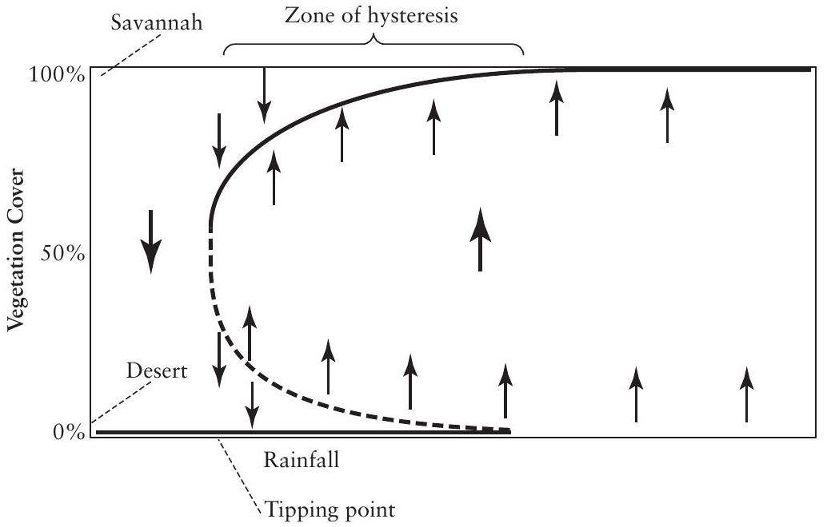
FIGURE 4.30. Example of a possible application of a saddle-node bifurcation (also more popularly known as a tipping point). Note that the vegetation cover is represented as a bold line, either a stable set of points (a node) with a solid bold line or an unstable set of points (a saddle) with a dashed bold line. As rainfall becomes less abundant, the vegetation cover slowly declines. However, there appears to be a tipping point, which is to say a point at which the vegetation cannot be sustained at all, and a desert results. This sort of arrangement also implies a zone of hysteresis; as the rainfall decreases, the system suddenly becomes a desert, but once it is in a desert, even though rainfall might increase again, the desert persists over the whole range of hysteresis.
attractors and tend to be far more complicated. Consider, for example, the constant predator model (equations 6 a and 6 b ). In figure 4.31 this model is plotted first (figure 4.31A) with parameters such that there are two attractors, to the left a point attractor at zero and to the right a strange attractor, and the two are separated by a separatrix. A small change in parameter results in the condition illustrated in figure 4.31B. A further small change in parameter causes the strange attractor to collide with the basin of the point attractor, eliminating the strange attractor entirely (figure 31C). What used to be parts of the trajectory of the strange attractor are now simply trajectories within the basin of attraction of the point attractor at zero. This sort of bifurcation phenomenon is known as a basin boundary collision because the basin of one attractor (the lower point attractor at zero) collides with the dynamic boundary of the strange attractor.
These examples, two structural instabilities associated with point attractors (period-doubling and saddle-node bifurcations) and a structural instability associated with a strange attractor (basin boundary collision), are but a few of the possibilities. Other structural instabilities are possible with more complicated models but are beyond the scope of this text.
Structural stability, then, is a very different form of stability. It involves the structure of the model as a whole and its qualitative behavior.
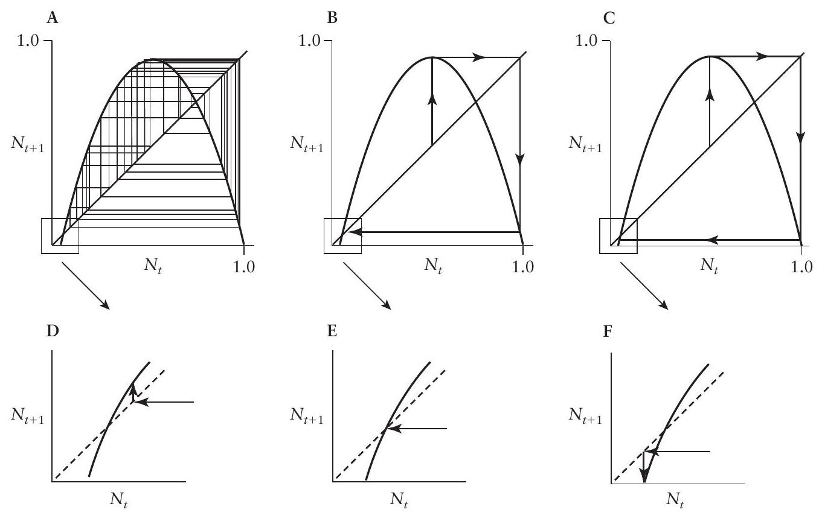
FIGURE 4.31. Illustration of a basin boundary collision. (A) Alternative attractors, one at zero and the other a strange attractor. (B) Bifurcation point. (C) After the basin boundary collides with the strange attractor, the trajectories that had been part of the attractor are now just part of the basin of attraction for the point attractor at zero. Panels D, E, and F are microscopic views of the area near zero, illustrating the positions of the trajectory emanating from the peak of the function.
Bifurcation Diagrams
Nonlinear models are frequently quite resistant to traditional analytical treatment. The one-dimensional maps (discrete time) and simple differential equations (continuous time) that have served to illustrate basic model behavior in this chapter are really only heuristic devices, enabling a partial understanding of the kinds of underlying structures that may give rise to complicated behaviors in more realistic models. For example, in more complicated predator-prey models, it is sometimes possible to construct an approximate one-dimensional map that captures the qualitative behavior of the more complicated model (e.g., Schaffer 1985). The basic structure of the one-dimensional model is then much easier to comprehend than the complicated model (a model of a model, so to speak).
One way of examining the general behavior of a complicated model when traditional analytical procedures are unavailable (i.e., because of the complexity of the model it is not possible to treat them analytically) is the bifurcation diagram. The various forms of bifurcation already described previously in this chapter (i.e., points of structural instability) are sometimes easily visualized in a "bifurcation diagram." Consider the standard logistic map,
$$N_{t+1}=λN_{t}\left(1−N_{t}\right).$$
As shown earlier, this model will have a bifurcation point at $λ=3$, with a simple equilibrium point when $λ<3$ and a periodic solution when $λ>3$. Specifically, the periodic solution is a "period-two" attractor, which is to say that the system oscillates between two points, exactly the same two points, forever. Consider, for example, the value of $λ=3.2$. If we begin with
$$N_{t}=0.8$$
we can easily calculate
$$N_{2}=3.2N_{1}\left(1−N_{1}\right)=3.2(0.8)(1−0.8)=3.2(0.8)(0.2)=0.512$$
Then we can substitute 0.512 to compute $N_{3}$, as follows:
$$N_{3}=3.2(0.512)(1−0.512)=3.2(0.512)(0.488)=0.8$$
which is the same number we originally started with. Thus we see that in this case the model will oscillate between 0.512 and 0.8 in perpetuity. This is a period-two (two values that are repeatedly visited) attractor.
In addition to the bifurcation point at $λ=3$, without further proof, if $λ$ becomes still larger, the period-two attractor converts into a period-four attractor, and if it becomes even larger, the period-four attractor converts into a period-eight attractor. (The interested reader can verify any of this with some simple experiments on a spreadsheet, following the approach of exercise 4.21.) In figure 4.32 this process is illustrated by way of a graph of $N^{∗}$
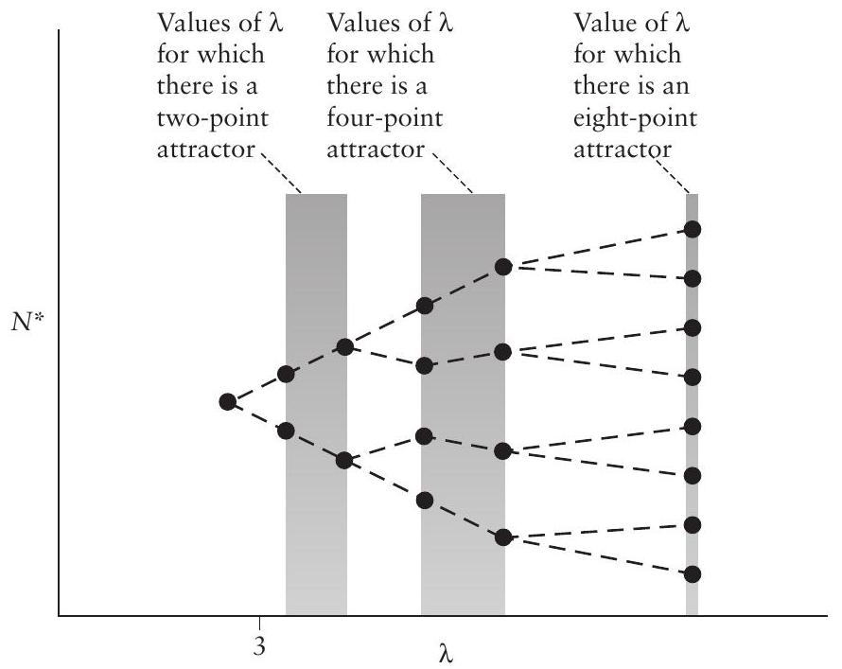
FIGURE 4.32. Illustration of the basic bifurcation process. Values of $λ$ that result in various attractor types are illustrated. Dashed lines connect these points in what is likely to be the intermediate values giving rise to the different attractors. Note the bifurcating nature of the picture, giving rise to the appellation bifurcation diagram.
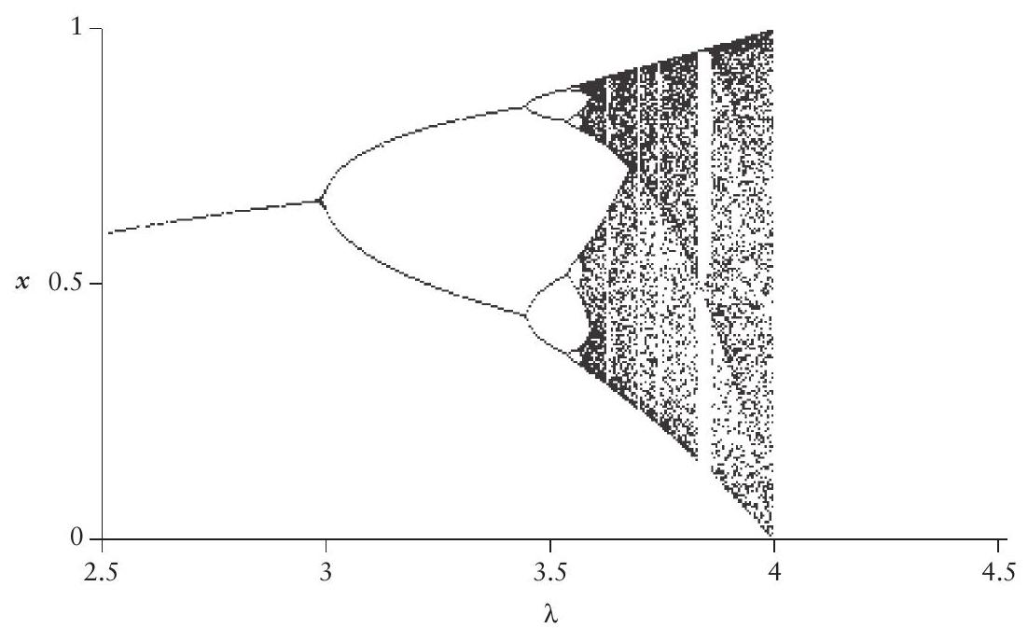
FIGURE 4.33. Bifurcation diagram for the logistic map. Note the similarity to figure 4.32. There is a clear period-doubling bifurcation at $λ=3$. At $λ=3.5$ another period doubling has already occurred and the system is in a four-point attractor. At $λ$ slightly larger than 3.5 another doubling occurs and the period eight attractor is visible. Note also the period-three "window." At $λ=4$ there is another bifurcation, as described earlier in the text.
against $λ$, where $N^{∗}$ is either the single equilibrium point for a point attractor or one of the repeated points of the periodic attractor.
In figure 4.32 the points referred to above are plotted, but they are also connected with dashed lines. It is intuitively obvious that the dashed lines represent an approximation of what the intermediate values of $N^{∗}$ would be, and it is clear that the dashed lines bifurcate at critical points. The diagram in figure 4.32 is thus referred to as a bifurcation diagram, and is an important tool used to study complex models.
Rather than choosing particular values of $λ$ and calculating the values of $N^{∗}$, we can simply calculate $N^{∗}$ for all of the values of $λ$, incrementing by some small amount. If we do this for the logistic map, we obtain the graph presented in figure 4.33.
The various attractors described in figure 4.32 are clearly visible in figure 4.33. Also visible is the bifurcation event at $λ=4$, fully explained in an earlier section. By examining such a bifurcation diagram it is frequently possible to gain an overall picture of how the model behaves. In this case there is a clear cascade of period-doubling events, from one to two to four to eight. In figure 4.34 a part of the bifurcation diagram is expanded $(λ=3.5−3.7)$.
Note that the period-doubling cascade is now visible for periods 4,8 , and 16. What happens is what one would expect, for the most part. The periods keep doubling, and the change necessary in $λ$ to get to the next doubling keeps decreasing. Eventually there has been such a massive period doubling that a remarkable point is reached at which one can simultaneously get all
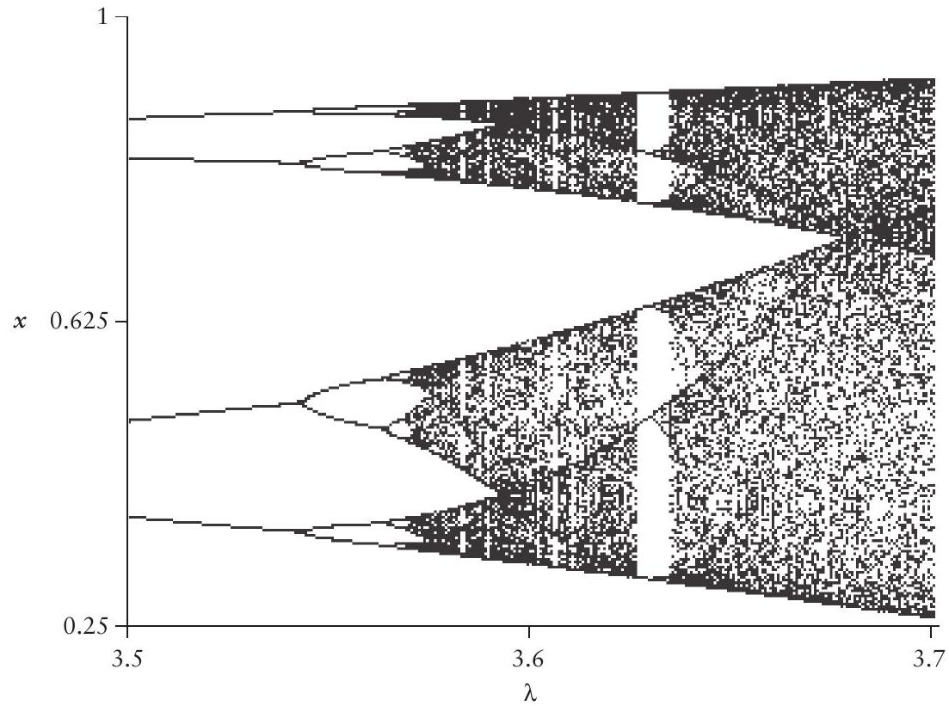
FIGURE 4.34. Close-up of part of the bifurcation diagram of figure 4.33.
possible periods as well as an uncountable number of aperiodic (i.e., never settling down to permanent values) attractors. This is the point at which the system is usually referred to as chaotic, and the manner in which chaos is approached here is referred to as the period-doubling route to chaos (there are other, qualitatively distinct, forms, but those are beyond the scope of this text). Just how complicated this behavior is can be appreciated by noting that there is a "window" in the original diagram (figure 4.33) in which there is an attractor of period 3. Where does a period-three attractor come from if the sequence goes $1,2,4,8,16,…$ ? Similarly, in figure 4.34 there is a window with a clear period-6 attractor. Where does that come from? Suffice it to say here that the explanation is mathematically complicated and beyond the intentions of this text. But biologically all it means is that the system is extremely unpredictable in the range of about $3.58<λ<4$, which is why the term chaos seems to be so popular.
As an example of the utility of bifurcation diagrams, consider the Tribolium model presented in chapter 2 . Recall that the population was divided into larvae, pupae, and adults and the nonlinear projection matrix model was given as
$$\left|\begin{matrix}L_{t+1} \\ P_{t+1} \\ A_{t+1}\end{matrix}\right|=\left|\begin{matrix}0 & 0 & f_{1}\left(L_{t}A_{t}\right) \\ p_{lp} & 0 & 0 \\ 0 & f_{2}\left(A_{t}\right) & p_{aa}\end{matrix}\right|\left|\begin{matrix}L_{t} \\ P_{t} \\ A_{t}\end{matrix}\right|,$$
where $L$ is the number of larvae, $P$ is the number of pupae, and $A$ is the number of adults. The functions $f_{1}$ and $f_{2}$ stipulate the nonlinear effect of cannibalism on the production of larvae by adults and the survival of pupae to adulthood, respectively. These functions are given as
$$f_{1}=\frac{b}{e^{c_{1}L_{t}+c_{2}A_{t}}}$$
and
$$f_{2}=\frac{b}{e^{c_{3}A_{t}}},$$
which are intended to incorporate the biological fact of cannibalism. This model would in fact be quite daunting if one were to try to solve it analytically, and it certainly does not lend itself to any obvious intuitive or heuristic explanation. But if one generates a bifurcation diagram, as Costantino et al. (1997), did, the diagram as pictured in figure 4.35 is obtained.
This bifurcation diagram was obtained by performing a series of experiments to estimate the parameters of the model and then substituting those values into the model, fixing all parameters except $c_{3}$. The parameter $c_{3}$ represents the rate of consumption of larvae per adult and is a parameter that Costantino and colleagues could experimentally manipulate in the laboratory. They next chose particular values of $c_{3}$ that represented various different dynamic situations, as indicated by the arrows on the top of the bifurcation diagram, and set up laboratory cultures corresponding to those particular values of $c_{3}$. Their results are shown in figure 4.36.
The open circles are the experimental results, and the closed circles are the expected results based on the model. The six different graphs correspond to
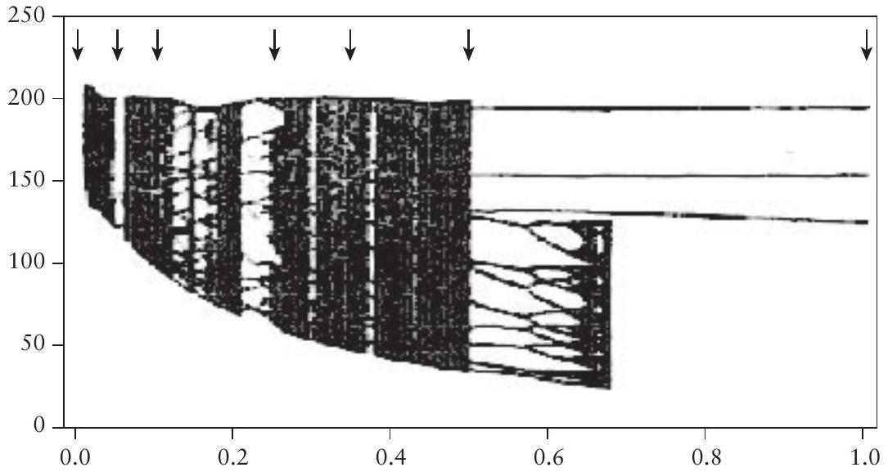
FIGURE 4.35. Bifurcation diagram of the Tribolium model. The bifurcation parameter is $c_{3}$, consumption of pupae by adults, and the variable plotted is the total population size. Reprinted with permission from Costantino et al. (1997). © 1997 American Association for the Advancement of Science.
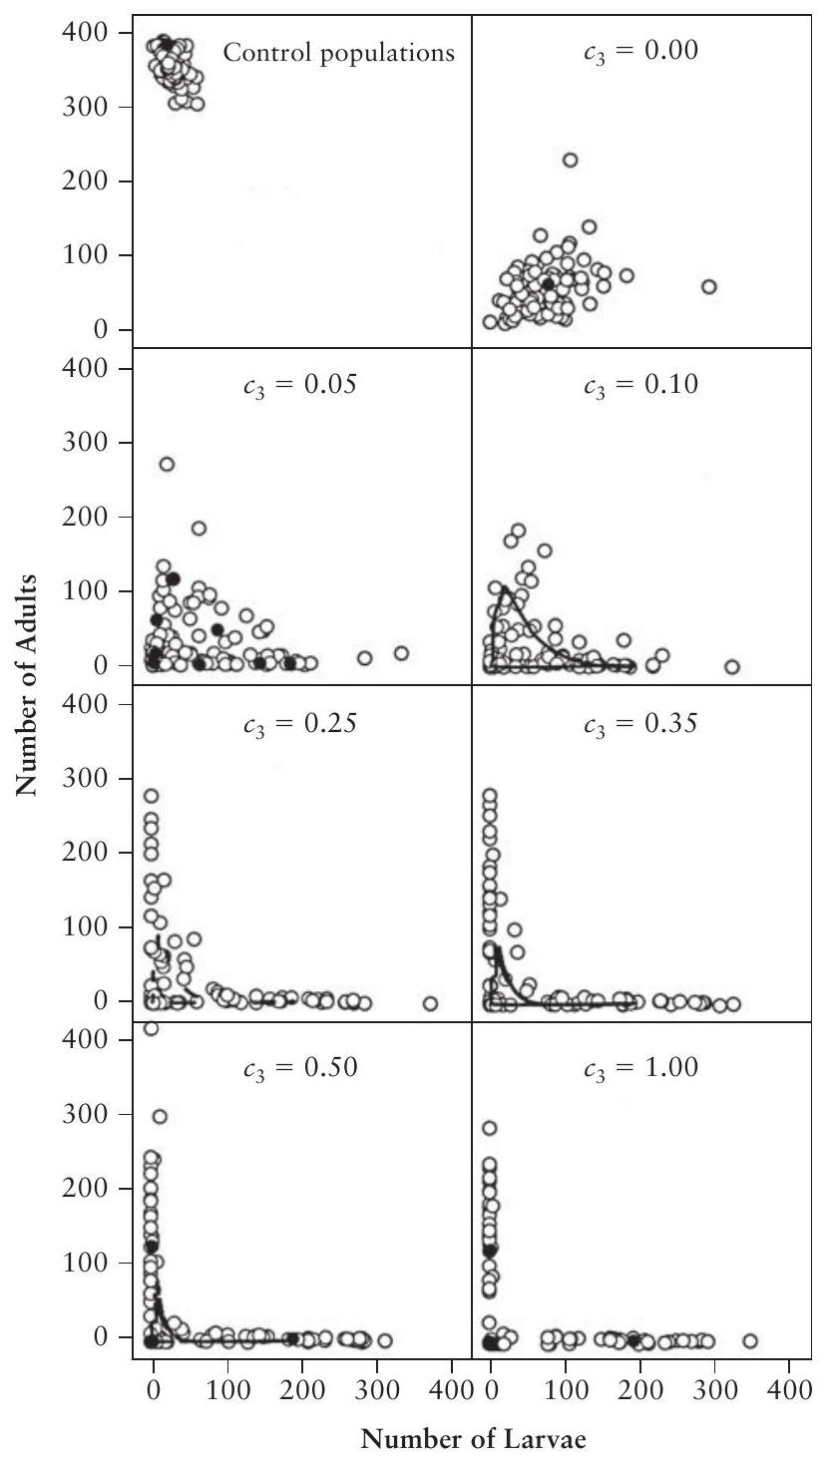
FIGURE 4.36. Experimental results of the Tribolium experiment of Costantino et al. (1997). The upper left-hand graph is the control; all others correspond to the values of $c_{3}$ indicated by the arrows in the upper part of figure 4.35 . Open circles are the observed values; closed circles, lines, or loops are the expectation from the model. Reprinted with permission from Costantino et al. (1997). © 1997 American Association for the Advancement of Science.
the positions of the arrows in figure 4.35 . There is a remarkable correspondence between what was expected and what is observed. What is even more remarkable is that the biologists on this team of investigators first thought that several of the theoretical outcomes would be impossible to achieve in the laboratory. But the data speak for themselves. Here the bifurcation diagram
was critical to the evaluation of the model to the point that predictions from the model came directly from the bifurcation diagram. The more traditional technique of comparing changes in the variables over time to the predictions over time generated by the model and by experiments could never have provided such a strong and elegant test of the model as did the analysis of the bifurcation diagram.
Concluding Remarks
In this chapter we have dealt with a panoply of different subjects related to the analysis of population models. These sorts of methods are currently the subject of intense investigation, and certainly this chapter will seem outdated within a few years. Nevertheless, these concepts are playing an increasingly important role in population modeling these days, and a minimal introduction, such as we have provided in this chapter, is essential background for understanding and using contemporary ecological approaches to population dynamics.
The primary focus in this chapter has been on the tools with which we can analyze models with complex behaviors, but the insights gained also lead to some important practical conclusions. We opened this chapter with notions of equilibrium and stability, long the bastions of creative thought in the search for a theory of ecosystems. The analyses in this chapter suggest that these notions may need to be abandoned, at least in terms of their classical meaning. For example, a dynamic system in chaotic behavior, such as that illustrated in figure 4.23B or figure 4.31A, is by classical standards unstable and in a strict mathematical sense unpredictable. Nevertheless, it has clear boundaries to its behavior and in another sense is quite stable-within the dynamic boundaries of its own region. Which sense is important to an ecosystem manager? Which sense is important in terms of understanding the ecosystem? Which sense is important in the context of natural selection?
These concepts may also suggest resolutions of various paradoxes of ecology. For example, the conundrum presented in the first paragraphs of this chapter, in which diversity is thought to generate stability yet some highly diverse systems are thought to be quite fragile, can be easily resolved. Perhaps the stability originally thought to result from the diversity actually refers to regional stability with a broad basin of attraction. The fragility that was actually observed when analyzing the question might then refer to the possibility that the basin itself could become smaller as diversity is reduced, increasing the likelihood that the basin could be traversed and the integrity of the system thus breached. Whether this is actually true of highly diverse systems is not the point here. Rather, these concepts suggest the way that some, perhaps many, natural historians have thought about this issue when they have pondered the relationship between diversity and stability.
In the sort of truly complex ecosystems likely to be encountered in the real world, the examples in this chapter will seem overly simplistic. Yet the Newtonian notion of point stability remains a stalwart of many thinkers in the
field of ecosystem dynamics, if only tacitly so. The simple one- and two-dimensional examples of this chapter are intended to introduce the notion of regional stability and the various complexities associated with it. Any realworld system will be multidimensional and ultimately must be represented in hyperspace. Figure 4.37 presents a "collapsed" hyperspace, a fictional two-dimensional representation of a multidimensional space. In figure 4.37 A is a system with four unstable points, yet there are two attractors that contain two of the four unstable points. The attractors are regionally stable. According to classic definitions of stability, this would be a very unstable system indeed. Traditional analysis of neighborhood stability would determine that there are four equilibrium points, all of which are unstable. Yet almost anyone would agree that this system is more "stable" in some vague ecological sense than the alternative system illustrated in figure 4.37B. This system has two stable points (one at zero), yet intuitively most would regard it as less stable than the one in figure 4.37A. Clearly, the notion of regional stability more clearly encompasses what most workers in ecology would describe as stable, and a regional attractor is similarly closer to intuitive notions of equilibrium than are the single points of the neighborhood stability sense.
The notion of structural stability represents a totally different idea of stability than does either the neighborhood or the regional sense and in a variety of ways is probably similar to what many in the environmental movement really mean when they refer to a stable system-a system that shows particular characteristics and will continue to show those characteristics even if small changes in conditions occur in the environment. So, for example, when the local environment changes such that a crop pest develops a locally elevated population density, the natural enemies of the traditional agroecosystem may respond by exerting control over that temporarily elevated population. A change had occurred in a parameter (the local environment that resulted in
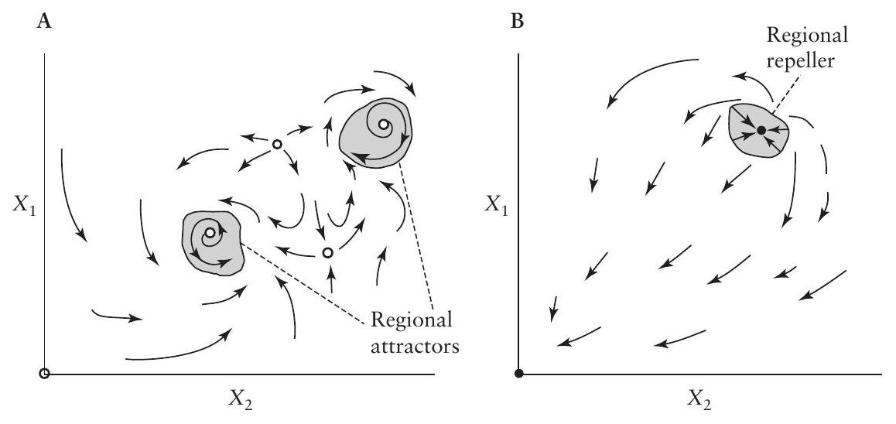
FIGURE 4.37. Theoretical situations in which (A) five-point repellers and two regional (strange) attractors coexist and (B) two-point attractors and a regional repeller coexist. The point attractors are illustrated by closed circles and the point repellers by open circles.
the elevated population density of the pest), but the system was structurally stable. No large change in its behavior resulted from this change in parameter.
Yet points of structural instability, especially bifurcation points, are sometimes exactly what we are looking for when we aim to understand or design ecosystems. Could it be, for example, that the conventional techniques for producing and processing tomatoes in California simply represent a syndrome of production, that another syndrome (the organic method, for example) might emerge if the parameters were changed somewhat, and that strategists aiming to convert to organic production might very well look for that break point, the bifurcation point that will carry the entire system into the organic mode? On the other hand, gradual changes in parameters may lead to a basin boundary collision in which a system originally held within a bounded attractor that represents a desired state of the ecosystem is engulfed in the basin of an attractor that includes undesired states. This phenomenon has been suggested as a possible mechanism for sudden extinction in natural populations (McCann and Yodzis 1994). This somewhat philosophical point will be left for the reader to ponder. Suffice it to say that the notion of structural stability is crucial in many ways to understand and/or design ecosystems.
Throughout this chapter we have minimized use of the word chaos, even though much of what is included is closely related to the field commonly known as chaos theory. We have done this because the word chaos has been something of a misnomer, leading to some confusion about the implications of chaotic behavior. The chief source of confusion comes from what has perhaps been an overemphasis on one particular aspect of chaos, sensitive dependence on initial conditions, especially in the popular literature on the subject. This particular characteristic is actually not even uniquely characteristic of strange attractors; unstable points exhibit the same phenomenon. However, the persistence of systems even though chaotic, coupled with the property of sensitive dependence on initial conditions, leads to the intuitive notion that they are inherently unpredictable. Although this is true in a narrow technical sense, it is certainly not the most important aspect of strange attractors (a better name than chaotic attractors).
Consider, for example, a tornado (Vandermeer and Yodzis 1999). That is most likely a chaotic object, an example of a strange attractor. It represents sensitive dependence on initial conditions in the following sense. Consider two particles of dust within the tornado. If they are very close to one another at one point in time, that fact has no bearing on where they will be with respect to one another in the near future. And how close they are now is not at all correlated with how close they will be in the future. So the future location of each dust particle is dependent on exactly where it is now and may change very dramatically with only a very slight change in its position now. That is sensitive dependence on initial conditions. But in fact that is not the interesting thing about a tornado. It is shaped like a funnel-that is, it has a morphology-and the whole thing travels along the ground wreaking devastation wherever it goes-that is, it has a behavior. Furthermore, if you see one coming toward you it is really quite a good idea to get out of the way,
even though it is chaotic and therefore "unpredictable." Sensitive dependence on initial conditions, the key idea of the unpredictability of chaos, refers only to the behavior of those dust particles inside the tornado. What is truly interesting about a tornado, what we wish to know and even predict, is perfectly knowable and predictable-thankfully. As was so eloquently stated in a recent summary of complexity theory:
First, control of natural phenomena begins to slip out of the grasp of observers, both because sensitivity to initial conditions severely limits the possibilities for prediction and control and because emergent properties of complex systems are unpredictable from a knowledge of parts. ... Second, these emergent properties can nevertheless be made intelligible in terms of appropriate descriptions of the processes involved, by using high-level concepts that capture their essential aspects. (Solé and Goodwin 2000, 27)
It is probably not of particular interest to determine whether a system is "formally" chaotic or not. An extremely complicated periodic attractor is, for all practical purposes, equivalent to a strange attractor anyway. If the behavior of the system is bounded and there is an instability within the bounded region, for all practical purposes it may be treated as if it were a strange attractor. Granted that there are cases of rather simple periodic attractors that can be analyzed in a traditional fashion. But many of the system behaviors that we can expect of populations embedded in ecosystems are likely to be very complicated, more like those of strange attractors than those of simple points or limit cycles. This does not mean that they cannot be understood any more than it means that a tornado has no shape. The focus should be not on the unpredictability but rather on the morphology of the attractorwhere are its boundaries, is it periodic-like, does it have dense and less dense regions, what is its overall shape, and so forth-the "appropriate descriptions" referred to in the above quotation. Much as we find in studying the morphology of organisms, there is no one defining feature of the morphology of strange attractors.
In studying the morphology of attractors, we have presented what seem to be some key principles. Where are the boundaries of a regional attractor? Is it structurally stable (in a practical sense)? What are the natures of nearby bifurcation points? Where are the basins of attraction? These and similar questions are likely to be the ones we are able to answer about ecosystems in general and, we furthermore suggest, are the ones we are more interested in answering anyway, in the pursuit of understanding and/or designing ecosystems.

