Service Learning
South Campus Center Closet
Supplies-
- Supply orders should be made at least 2 weeks in advance.
  - If requests are made less than 2 weeks in advance, we cannot guarantee that the items will arrive in time.
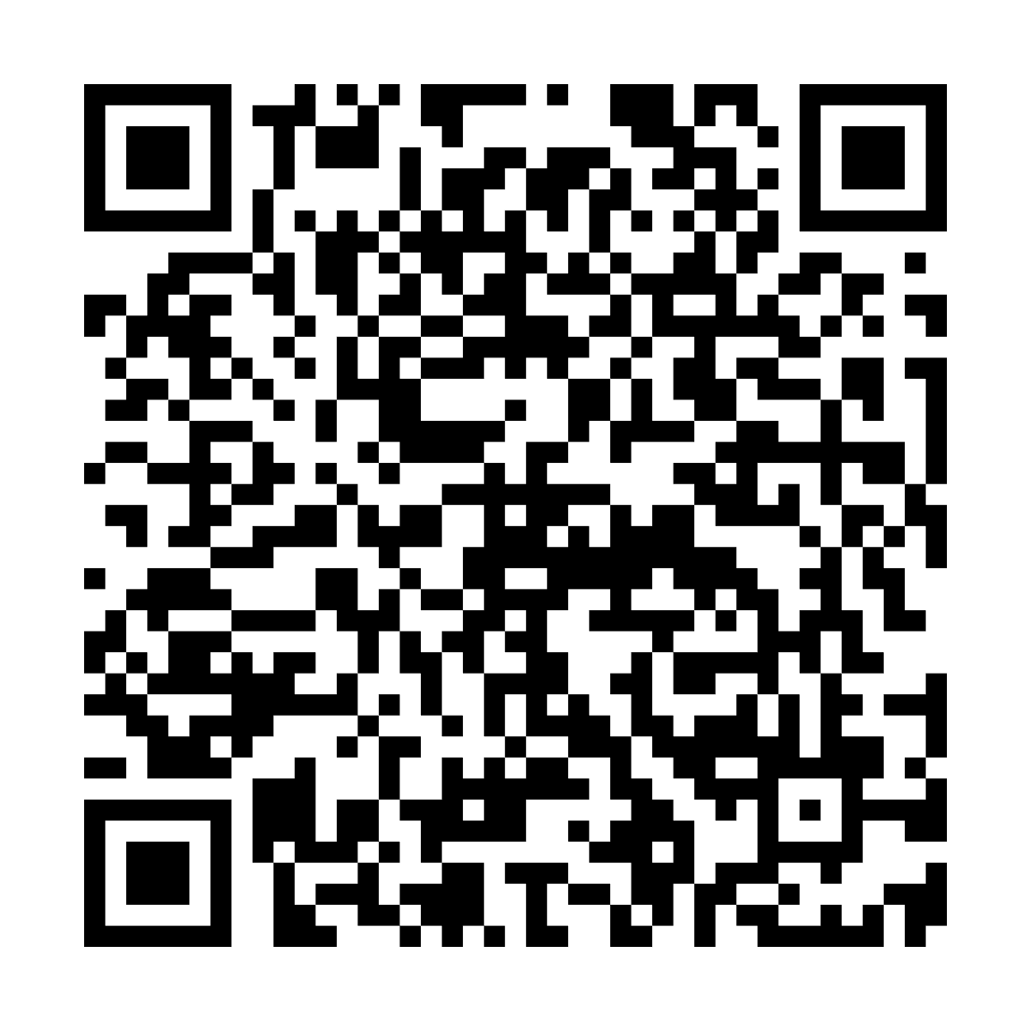
- Orders should be submitted using this survey QR Code:

- Supplies will be placed in a labeled box in the SCC Closet pick-up area for you to pick up.
  - Whoever submitted the order survey will be notified once the items are ready to be picked up. Please do not grab other groups’ items and please try to grab your items within a few days of notification.
- If you take general stocked items from the closet and the supply is running low, please notify Addison ASAP.
- There are 30-minute load/unload parking spots in front of SCC for pick up.
- Please clean up after yourselves!
  - To maintain a safe an organized environment, bins and miscellaneous supplies should never be left on the floor. Once you’ve organized your group’s shelf space, if you’re not sure where to stash extra items, email somserve@uw.edu and we can help.
IMPORTANT: If supplies are being delivered to your home or you are picking up items directly from a store, please remember to send a signed and dated photo of the packing slip(s)/receipts to somserve@uw.edu. If one does not come with the order, please take a photo of the order and email somserve@uw.edu confirming that you received it.
Biohazard- please place all biohazard waste in the large blue bin in the SCC Closet. (lowest shelf of the unit on the left as you walk in). If the bin is looking full, please notify Addison so she can empty it.
Autoclave (sterilization of durable equipment) – please notify Addison when you need equipment sterilized.

Contact Information
Addison Rittenhouse- Student Engagement Specialist
somserve@uw.edu

